CHAPTER 1 : Introduction of Organization

: About CFEES
The Centre for Fire, Explosive and Environment Safety (CFEES) is one of the premier laboratories of the Defence Research and Development Organisation (DRDO), functioning under the Ministry of Defence, Government of India. Located in Delhi, CFEES is dedicated to research, development, testing, and evaluation in the fields of fire safety, explosive safety, environmental protection, chemical hazard management, and safety engineering. The laboratory plays a significant role in ensuring the safety, reliability, and operational effectiveness of defence equipment, military infrastructure, and strategic installations used by the Indian Armed Forces.
CFEES was established with the objective of providing scientific and technological solutions for preventing fire hazards, mitigating explosion risks, and minimizing environmental impacts associated with defence activities. The laboratory integrates scientific research, engineering practices, and advanced technologies to develop innovative safety systems that support various defence organizations and research establishments across the country. Through continuous innovation and interdisciplinary research, CFEES contributes significantly to strengthening India's defence preparedness while ensuring environmental sustainability.
During the internship at CFEES, valuable exposure was gained to a professional research environment where scientific discipline, technical learning, and practical implementation are given high importance. The organization provided an excellent opportunity to understand real-world project development processes.


Figure 1.1: Centre for Fire, Explosive and Environment Safety (CFEES), DRDO
Fire Safety Research
Fire safety is one of the primary research domains of CFEES. Modern defence platforms such as naval ships, aircraft, combat vehicles, ammunition depots, laboratories, and industrial facilities are exposed to various fire hazards due to the presence of combustible materials, electrical systems, fuel storage, and explosives. To address these challenges, CFEES conducts extensive research on fire prevention, fire detection, fire suppression, and post-fire damage assessment.
Scientists at CFEES develop advanced fire detection systems capable of identifying fire incidents at an early stage using intelligent sensors and monitoring techniques. Research is also carried out on automatic fire suppression systems utilizing water mist technology, clean agents, foam-based extinguishing systems, gaseous suppression systems, and advanced firefighting equipment. Fire simulation studies are conducted to understand fire behaviour under different operational conditions, enabling the design of effective safety measures for defence installations.
The laboratory also evaluates the fire resistance of construction materials, protective clothing, defence equipment, and military infrastructure. These studies help improve safety standards and reduce the risk of fire-related accidents during military operations and industrial activities.
Explosive Safety
Another major area of specialization at CFEES is explosive safety engineering. Defence organizations frequently handle highly sensitive explosives, propellants, missiles, ammunition, and pyrotechnic materials that require strict safety measures during manufacturing, transportation, storage, and operational deployment.
CFEES performs detailed hazard analysis and risk assessment to evaluate the behaviour of explosive materials under various environmental and operational conditions. Scientists study blast pressure, fragmentation effects, thermal radiation, accidental detonation scenarios, and shock wave propagation to develop effective safety guidelines.
The laboratory also establishes safe storage distances, blast-resistant structures, protective barriers, and explosion mitigation techniques for ammunition depots and defence facilities. These research activities significantly reduce operational risks and ensure the safe handling of hazardous explosive materials used by the Indian Armed Forces.
Environmental Protection
Environmental protection is another important research area of CFEES. Defence establishments often generate chemical waste, industrial emissions, hazardous substances, and environmental pollutants during manufacturing and operational activities. CFEES develops technologies that minimize environmental impact while maintaining operational efficiency.
Research activities include air pollution monitoring, wastewater treatment, hazardous waste management, environmental impact assessment, and remediation technologies. The laboratory also studies occupational health hazards and develops protective measures for defence personnel working in chemically hazardous environments.
CFEES contributes towards sustainable defence development by ensuring compliance with environmental regulations and promoting eco-friendly engineering practices. These initiatives support both environmental conservation and long-term operational safety.
Research Facilities and Technical Infrastructure
CFEES is equipped with advanced laboratories, testing facilities, simulation centers, and scientific instruments that enable high-quality research and development activities. The laboratory possesses specialized facilities for fire testing, explosion analysis, environmental monitoring, material characterization, chemical analysis, computational modelling, and safety evaluation.
Modern computer systems, simulation software, environmental monitoring equipment, thermal analysis instruments, blast testing facilities, and fire behaviour laboratories allow researchers to conduct accurate experiments under controlled conditions. These facilities support the design, testing, validation, and certification of safety technologies developed for defence applications.
The multidisciplinary research environment at CFEES encourages collaboration among scientists, engineers, technical officers, research scholars, and industry experts, leading to the development of innovative defence solutions.
Major Projects and Research Contributions
Over the years, CFEES has successfully undertaken numerous research projects related to fire protection systems, explosion safety, environmental monitoring technologies, protective equipment, hazard assessment, and disaster management. The laboratory has developed specialized technologies for military vehicles, naval platforms, ammunition storage facilities, defence laboratories, and industrial establishments.
The laboratory also provides scientific consultancy, technical testing, safety certification, and expert recommendations to various defence organizations. Continuous research in emerging technologies enables CFEES to address evolving challenges associated with modern defence systems and critical infrastructure protection.
Role in Defence Research
CFEES plays a vital role within DRDO by providing scientific expertise in safety engineering and environmental protection. The technologies developed by the laboratory directly contribute to improving the safety, reliability, and operational readiness of defence equipment and military infrastructure.
Apart from research and development, CFEES actively collaborates with other DRDO laboratories, government organizations, academic institutions, and industries to develop integrated technological solutions for national defence. The laboratory also supports disaster management, chemical hazard response, industrial safety, and risk assessment activities that are essential for maintaining defence preparedness.
Importance of CFEES within DRDO
CFEES is considered one of the most important specialized laboratories within DRDO because it focuses on safeguarding defence personnel, equipment, and strategic assets from fire, explosion, and environmental hazards. Its research ensures that advanced defence technologies operate safely and efficiently under diverse operational conditions.
The laboratory's contributions extend beyond traditional defence applications by promoting sustainable engineering practices, occupational safety, environmental conservation, and disaster preparedness. Through continuous innovation, scientific excellence, and multidisciplinary research, CFEES supports DRDO's mission of achieving technological self-reliance and strengthening India's national security.

: Work Environment
The Centre for Fire, Explosive and Environment Safety (CFEES), DRDO provides a highly professional, disciplined, and research-oriented working environment that promotes innovation, technical excellence, and continuous learning. As one of the premier laboratories of the Defence Research and Development Organisation, CFEES maintains high standards of scientific research, engineering practices, and project execution. During the internship, exposure to this environment provided valuable insights into the functioning of a government research organization and helped in developing both technical competence and professional ethics.
Research Environment
The research environment at CFEES is characterized by systematic planning, scientific investigation, and collaborative problem-solving. Various research activities are carried out in specialized laboratories where scientists, engineers, and technical officers work together on defence-related projects. Every project is executed using a structured methodology involving requirement analysis, design, implementation, testing, validation, and documentation.
The atmosphere encourages analytical thinking and innovation while ensuring that every solution meets high standards of quality, reliability, and security. Team members continuously explore new technologies and engineering approaches to solve practical defence problems. Working in such an environment provided valuable exposure to industrial research practices and demonstrated how scientific knowledge is transformed into real-world applications.
Software Development Culture
The software development culture at CFEES emphasizes quality, modularity, maintainability, and security throughout the software development life cycle. Projects are developed using well-defined coding practices and structured programming techniques to ensure that applications remain scalable and easy to maintain. During the internship, software development activities involved designing user interfaces, implementing backend logic, integrating databases, and testing application functionalities.
Modern development tools and frameworks were utilized for building web applications. The project followed a modular architecture in which different functionalities were divided into independent components, allowing easier development, debugging, and future enhancements. Emphasis was also placed on writing reusable code, validating user inputs, and maintaining consistency across different application modules.
Documentation Standards
Documentation is considered an essential part of every software development project at CFEES. Proper documentation ensures that project requirements, system architecture, database structures, program logic, and implementation details are clearly recorded for future reference. Every stage of development is documented carefully to facilitate maintenance, upgrades, and knowledge transfer.
During the internship, project documentation included system requirements, database design, module descriptions, testing procedures, and implementation details. Maintaining organized documentation improved understanding of the project structure and ensured that future modifications could be performed efficiently. The importance of preparing technical reports, maintaining version records, and documenting project progress was emphasized throughout the internship.
Professional Ethics
Professional ethics form the foundation of the working culture at CFEES. Every employee and intern is expected to maintain honesty, integrity, confidentiality, punctuality, and accountability while performing assigned responsibilities. Respect for organizational policies, responsible use of resources, and commitment to quality are considered essential professional values.
As an intern, adherence to these ethical principles was expected during project development and day-to-day activities. Timely completion of assigned tasks, maintaining professional behavior, respecting mentors and colleagues, and following organizational guidelines contributed to developing a disciplined work ethic. These values are important not only in defence organizations but also throughout a professional career in the software industry.
Security Protocols
Since CFEES is a defence research laboratory, maintaining security and confidentiality is of utmost importance. Access to work areas, research facilities, and technical information is carefully regulated through established security protocols. All personnel are required to comply with organizational policies regarding data protection, information confidentiality, and authorized access.
During the internship, the project was developed within a secure local development environment using XAMPP, PHP, MySQL, and React. The application was designed to operate without an internet connection, ensuring that organizational data remains within the local system. Role-based authentication, secure session management, controlled user access, and database validation mechanisms were implemented as part of the software to support secure operation and protect sensitive information.
Collaboration and Teamwork
Collaboration is an important aspect of the work culture at CFEES. Scientists, technical officers, engineers, and interns work together to achieve project objectives through effective communication and knowledge sharing. Technical discussions and collaborative problem-solving help improve project quality while encouraging innovation and continuous improvement.
Throughout the internship, regular interactions with mentors and technical staff provided opportunities to discuss project requirements, clarify technical concepts, and receive constructive feedback. Team collaboration enhanced the overall learning experience and demonstrated the importance of coordinated efforts in successfully completing software development projects.
Guidance from Scientists and Technical Officers
One of the most valuable aspects of the internship was the continuous guidance provided by experienced professionals. The project was carried out under the supervision of Sh. T. S. Rathore, Scientist 'F', with technical guidance from Sh. Pawan Kumar, Technical Officer 'B'. Their mentorship helped in understanding project objectives, selecting appropriate technologies, designing system architecture, and implementing application modules according to organizational requirements.
Regular review meetings, technical discussions, and constructive suggestions helped improve coding practices, debugging techniques, database design, and overall software quality. The guidance received throughout the internship significantly enhanced both technical knowledge and professional confidence.
Learning Through Practical Implementation
The internship provided extensive opportunities for practical learning through the development of a real-world software application. Instead of limiting learning to theoretical concepts, emphasis was placed on implementing complete software modules such as user authentication, inventory management, transfer request processing, master configuration, profile management, and role-based access control.
Working on an actual organizational project improved understanding of full-stack web development, database management, API integration, software testing, debugging, and system deployment. Practical implementation strengthened problem-solving abilities and provided valuable experience in developing secure and maintainable enterprise applications. The exposure gained during the internship established a strong foundation for future professional work in software engineering and information technology.

CHAPTER 2 : Introduction of the Internship

2.1 : Internship Overview
The internship was carried out at the Centre for Fire, Explosive and Environment Safety (CFEES), one of the premier laboratories of the Defence Research and Development Organisation (DRDO), operating under the Ministry of Defence, Government of India. The internship was undertaken as a part of the Bachelor of Technology (B.Tech.) curriculum with the objective of gaining practical exposure to modern software development technologies and understanding the software development practices followed in a research-oriented defence organization.
The internship was conducted in the software development environment of CFEES, where digital solutions are developed to support various administrative and technical activities within the organization. The assigned project focused on the development of a Web Based Inventory Management System, which was designed to digitize inventory management processes, improve record maintenance, and provide efficient tracking of hardware resources within the organization. The project emphasized secure data management, user authentication, role-based access control, and centralized inventory administration.
The internship duration was from 15 January 2026 to 30 June 2026, during which extensive practical exposure was gained in full-stack web application development. The project was carried out under the supervision of Sh. T. S. Rathore, Scientist 'F', whose guidance and technical expertise played a significant role in understanding project requirements, software architecture, and implementation strategies. Continuous support and technical guidance were also provided by Sh. Pawan Kumar, Technical Officer 'B', who assisted in solving technical challenges, reviewing implementation progress, and ensuring that the developed application met organizational requirements.
The assigned project, titled "Web Based Inventory Management System," aimed to replace traditional manual inventory management methods with a secure and centralized digital platform. The application was developed using modern full-stack technologies including React (Vite) for the frontend, PHP for backend server-side programming, and MySQL as the relational database management system.
Additional development tools such as XAMPP, Visual Studio Code, Node.js, and Google Chrome Developer Tools were used throughout the project development process. The application was designed to operate on a local server environment without requiring an internet connection, making it suitable for secure internal deployment within an organizational network.
The project incorporated several integrated modules to support different organizational functions. These included a secure authentication system for user login and registration, an inventory management module for maintaining hardware records, a transfer request module for managing asset movement, a master configuration module for dynamic system configuration, and a user management module implementing role-based access control. Together, these modules formed a complete web-based solution for efficient inventory administration.
The internship was conducted in the domain of Full Stack Web Development, providing practical experience in both frontend and backend application development. The frontend interface was designed using React components to create a responsive and interactive user experience, while the backend logic was implemented using PHP to process business operations, handle authentication, and communicate with the MySQL database. REST-based APIs were used for data exchange between the frontend and backend, enabling smooth interaction between different application layers.
The internship also provided practical exposure to software engineering principles such as requirement analysis, database design, modular programming, API integration, debugging, validation, testing, and documentation. Rather than focusing only on coding, emphasis was placed on developing a complete software solution following a structured software development life cycle. Every module of the application was designed, implemented, tested, and integrated systematically to ensure correctness, maintainability, and scalability.
Another important objective of the internship was to understand how software applications are developed within a professional research organization. Regular interactions with scientists and technical officers provided valuable insights into project planning, quality assurance, coding standards, software security, and documentation practices. Constructive feedback received during technical discussions helped improve problem-solving abilities and strengthened understanding of enterprise application development.
The internship also contributed significantly to professional development by improving communication skills, technical documentation, analytical thinking, teamwork, and time management. Working in a disciplined defence research environment highlighted the importance of professional ethics, responsibility, confidentiality, and adherence to organizational standards while developing software systems.
Overall, the internship provided an excellent opportunity to apply academic knowledge to a real-world project while gaining practical experience in full-stack web development. The successful development of the Web Based Inventory Management System enhanced technical competence in React, PHP, MySQL, API integration, and database management, while also providing valuable exposure to industrial software development practices. The knowledge and experience gained during this internship established a strong foundation for future academic pursuits and professional growth in the field of software engineering and information technology.

2.2 : Objectives of the Internship
The internship at the Centre for Fire, Explosive and Environment Safety (CFEES), Defence Research and Development Organisation (DRDO) was undertaken with the primary objective of gaining practical exposure to modern software development technologies and understanding the complete software development life cycle in a professional research environment. The internship provided an opportunity to apply theoretical knowledge acquired during academic studies to the development of a real-world application titled "Web Based Inventory Management System." The project aimed to improve organizational inventory management through a secure, efficient, and user-friendly web application.
One of the major objectives of the internship was to learn Full Stack Web Development by working on both frontend and backend technologies. The project involved designing responsive user interfaces using React (Vite), implementing server-side logic using PHP, and integrating the application with a MySQL relational database. This provided practical understanding of how different layers of a web application interact to deliver complete business functionality. Learning frontend design, backend programming, and database management together helped in developing a comprehensive understanding of full-stack software development.
Another important objective was to develop an enterprise-level web application capable of managing inventory records in a structured and secure manner. The application was designed to replace manual inventory management with a centralized digital system capable of storing, updating, searching, and managing hardware assets efficiently. The project emphasized modular architecture, maintainability, scalability, and user-friendly operation, which are essential characteristics of enterprise software solutions.
The internship also focused on database design and management, enabling practical understanding of relational database systems. The objective was to design an efficient database capable of storing user information, inventory records, transfer requests, and master configuration data while maintaining data integrity and minimizing redundancy. Database normalization principles, table relationships, primary keys, foreign keys, and SQL operations were implemented to ensure reliable and efficient data management within the application.
Another significant objective was to gain experience in API (Application Programming Interface) development and integration. The project required communication between the React frontend and the PHP backend using REST-based APIs. API endpoints were developed to process user requests, retrieve inventory data, manage authentication, and perform CRUD operations. This objective helped in understanding client-server architecture and the exchange of data between different software components through structured API communication.
Implementing secure authentication mechanisms was another key objective of the internship. The application required a login system capable of verifying user credentials, creating secure user sessions, and restricting unauthorized access to protected resources. Session management, login validation, logout functionality, and role verification were implemented to ensure secure application access. This objective improved understanding of application security and user authentication techniques used in modern web applications.
The internship also aimed to provide practical experience in implementing CRUD (Create, Read, Update, Delete) operations, which form the foundation of database-driven web applications. CRUD functionalities were developed for user management, inventory management, transfer requests, and master configuration modules. These operations enabled efficient creation, retrieval, modification, and deletion of records while maintaining database consistency and supporting real-time data management.
One of the primary objectives of the project was to automate inventory management processes within the organization. The developed system allows administrators to manage hardware assets digitally, assign inventory to employees, monitor equipment status, maintain transfer records, and generate an organized inventory database. By automating these operations, the system reduces manual effort, minimizes errors, improves data accessibility, and enhances overall organizational efficiency.
The internship also focused on implementing Role-Based Access Control (RBAC) to ensure secure and controlled access to system functionalities. Different user roles such as Administrator, Inventory Head, and Normal User were assigned appropriate permissions according to their responsibilities. This objective improved understanding of authorization mechanisms commonly used in enterprise applications and demonstrated how security can be enhanced by restricting user access based on predefined roles.
Another important objective was to develop an offline web application capable of operating within a secure local environment. The Inventory Management System was developed using XAMPP, allowing it to run entirely on a local server without requiring an internet connection. This design approach makes the application suitable for deployment within organizations where secure internal access is preferred over cloud-based systems. The offline architecture also improves data confidentiality and ensures uninterrupted operation within local networks.
Overall, the internship objectives were successfully achieved through the design and implementation of a complete full-stack web application. The experience provided valuable practical knowledge in software engineering, database management, web technologies, authentication systems, API integration, and enterprise application development. In addition to technical skills, the internship also enhanced problem-solving ability, analytical thinking, professional discipline, and project management skills, thereby preparing for future opportunities in software development and information technology.

2.3 : Roles and Responsibilities
During the internship at the Centre for Fire, Explosive and Environment Safety (CFEES), Defence Research and Development Organisation (DRDO), I was assigned the responsibility of developing a Web Based Inventory Management System under the guidance of Sh. T. S. Rathore, Scientist 'F', and Sh. Pawan Kumar, Technical Officer 'B'. The project involved the complete software development life cycle, beginning with requirement analysis and continuing through system design, implementation, testing, debugging, and documentation. The internship provided an opportunity to work on a real-world software application while applying modern full-stack web development technologies.

Requirement Analysis
One of the primary responsibilities was to understand the functional requirements of the Inventory Management System. The existing inventory management process was analyzed to identify its limitations and determine how a web-based solution could improve efficiency and accuracy. Discussions with mentors helped in understanding the expected workflow of inventory tracking, user management, transfer requests, and administrative control. Based on these requirements, the overall system architecture and module structure were planned before development began.
User Interface (UI) Design
Another important responsibility involved designing an interactive and user-friendly interface for the application. The frontend was developed using React (Vite) with the objective of providing a clean, responsive, and organized interface for different categories of users. Individual screens such as the login page, registration page, inventory dashboard, user profile, transfer request page, and master configuration module were designed to ensure smooth navigation and ease of use. The interface was developed with consistency in layout, proper alignment of components, responsive design principles, and improved user experience.
React Frontend Development
The frontend development of the project was carried out using React.js with the Vite development environment. React components were created for different application modules, allowing the interface to remain modular, reusable, and easy to maintain. State management, event handling, form validation, and dynamic rendering were implemented to improve application responsiveness. The frontend was designed to communicate efficiently with backend APIs while providing users with a seamless experience during inventory management operations.
PHP API Development
The backend logic of the application was implemented using PHP, which handled all server-side processing and business logic. PHP scripts were developed to process user requests, authenticate users, validate data, manage inventory records, and perform database operations. Separate API endpoints were created for functionalities such as login, registration, inventory management, transfer requests, profile updates, and user administration. Backend validation mechanisms were also implemented to ensure secure processing of user inputs and maintain application reliability.
MySQL Database Management
A significant responsibility during the internship involved designing and managing the MySQL relational database used by the application. Database tables were created for storing user information, inventory records, transfer requests, and master configuration data. Proper relationships between tables were established using primary and foreign keys to maintain data consistency and integrity. SQL queries were written to retrieve, insert, update, and delete records efficiently while minimizing redundancy and ensuring organized data storage.
API Integration
The project required continuous integration between the React frontend and the PHP backend. API communication was implemented using HTTP requests and JSON responses, allowing different modules of the application to exchange information efficiently. Every frontend operation such as user login, inventory retrieval, data insertion, profile updates, and transfer request processing interacted with backend APIs. Ensuring smooth communication between the client interface and the server-side application was an important responsibility throughout the development process.
Authentication and Authorization
Implementing a secure authentication mechanism was another major responsibility. The application was designed to verify user credentials during login and allow access only to authenticated users. Role-based authorization was implemented to differentiate system privileges for Administrators, Inventory Heads, and Normal Users. Authentication logic included user verification, secure login processing, password validation, and controlled access to protected application modules.
CRUD Operations
One of the core responsibilities involved implementing complete CRUD (Create, Read, Update, Delete) functionality across different modules of the application. Users and administrators could create new inventory records, retrieve existing data, update information whenever required, and remove obsolete records from the database. Similar CRUD operations were implemented for user management, transfer requests, and master configuration modules. These operations formed the foundation of the application's functionality and enabled efficient management of organizational data.
Testing and Validation
Testing was carried out continuously during the development process to verify that each module functioned correctly. Functional testing was performed for login authentication, inventory operations, user management, transfer requests, and master configuration features. Input validation was implemented on both frontend and backend to prevent incorrect data entry and maintain database integrity. The application was tested using different user roles to ensure that access permissions and system functionalities worked as intended.
Debugging and Error Resolution
Debugging formed an important part of the development process. Various technical issues such as API communication errors, database connectivity problems, session-related issues, frontend rendering bugs, and validation failures were encountered during implementation. Browser developer tools, PHP error logs, and SQL query testing were used to identify and resolve these problems systematically. Continuous debugging improved application performance, stability, and reliability.

CHAPTER 3 : Project Development

3.1 : Project Overview
The Web Based Inventory Management System was developed to provide a secure, efficient, and centralized solution for managing inventory records within an organization. In many organizations, inventory management involves maintaining information about hardware assets, equipment allocation, employee assignments, and inventory movement. Managing these records manually often leads to inefficiency, inaccurate documentation, duplication of records, and difficulty in retrieving information. To overcome these challenges, a web-based inventory management solution was designed and implemented using modern full-stack web technologies.
The developed system provides a centralized platform through which administrators and authorized users can manage inventory assets, monitor hardware allocation, maintain employee records, process transfer requests, and update inventory information in real time. The application is designed to operate on a secure local server using React (Vite) as the frontend framework, PHP as the backend technology, and MySQL as the database management system. Since the application operates entirely on a local network using XAMPP, it does not require an internet connection, making it suitable for deployment within secure organizational environments such as research laboratories and government institutions.
Problem Statement
Many organizations continue to manage inventory records using manual registers, spreadsheets, or standalone documents. These traditional methods require considerable effort to maintain and update records, especially when the inventory size increases over time. Manual record management is often associated with several operational problems, including duplicate entries, missing records, delayed updates, incorrect information, and difficulties in locating inventory items.
Another challenge is the lack of centralized access to inventory information. Different departments may maintain separate records, making it difficult to track hardware allocation, employee assignments, equipment transfers, and maintenance history. Manual systems also provide limited security because unauthorized modifications can occur without proper authentication or user accountability.
As organizations expand, manual inventory management becomes increasingly inefficient and time-consuming. Therefore, there is a growing need for a computerized inventory management system that provides centralized control, secure access, and efficient management of organizational resources.
Need for an Inventory Management System
An effective inventory management system is essential for maintaining accurate information about organizational assets and ensuring their efficient utilization. Hardware resources such as computers, printers, networking devices, and other electronic equipment represent valuable organizational assets that require proper documentation and continuous monitoring.
A web-based inventory management system enables organizations to maintain a centralized database of all inventory assets while allowing authorized personnel to update information whenever required. It simplifies asset allocation, employee assignment, inventory transfers, maintenance tracking, and administrative monitoring through a single integrated platform.
The system also improves transparency by recording every inventory transaction digitally. Administrators can quickly search inventory records, verify asset ownership, identify available resources, and generate accurate reports whenever required. Such automation significantly improves operational efficiency and reduces the possibility of human error.
Existing Manual Process
Before the implementation of the proposed system, inventory management was generally performed through manual methods involving registers, paper documents, and spreadsheet-based records. Whenever new hardware was purchased or transferred between departments, records had to be updated manually. Similarly, changes in employee assignments, equipment locations, or inventory status required additional manual modifications.
Searching for specific inventory records was often time-consuming because users had to examine multiple documents or spreadsheets. Maintaining consistency across different records was also difficult, particularly when multiple users handled inventory information simultaneously.
The absence of centralized data storage further increased the chances of data redundancy, inconsistencies, and record duplication. Manual systems also lacked proper authentication and access control, making inventory information vulnerable to unauthorized modifications.
Limitation of the Existing System
The traditional inventory management approach has several limitations that affect organizational efficiency. One of the major limitations is the dependence on manual data entry, which increases the possibility of human errors during record creation and modification.
Searching for inventory information becomes increasingly difficult as the number of assets grows. Manual records also consume more storage space and require significant effort for maintenance and verification.
Another important limitation is the absence of role-based access control. Without proper authentication mechanisms, sensitive inventory information may be accessed or modified by unauthorized individuals. Manual systems also lack automated approval workflows for inventory transfers and updates, resulting in reduced accountability.
Furthermore, manual inventory management provides limited reporting capabilities and makes it difficult to monitor equipment availability, hardware allocation, and maintenance status in real time.
Proposed Solution
To overcome the limitations of manual inventory management, a Web Based Inventory Management System was developed. The proposed solution provides a centralized digital platform for maintaining inventory records, managing user accounts, processing inventory transfers, and monitoring organizational assets efficiently.
The application includes multiple integrated modules such as Authentication, Inventory Management, Transfer Request Management, Master Configuration, User Management, and Profile Management. Each module performs a specific function while working together as part of a unified system.
Role-Based Access Control (RBAC) has been implemented to ensure secure access to application functionalities. Different users such as Administrators, Inventory Heads, and Normal Users are assigned specific permissions according to their responsibilities. Authentication and session management mechanisms prevent unauthorized access and improve overall application security.
The system has been developed using React (Vite) for building a modern and responsive user interface, PHP for implementing server-side business logic, and MySQL for reliable database management. Since the application is deployed on a local XAMPP server, it operates efficiently without requiring an internet connection, making it suitable for secure organizational environments.
Objectives of the Project
The primary objective of the project is to develop a secure and efficient inventory management system that simplifies inventory administration and reduces dependency on manual processes. The project aims to centralize inventory records, improve data accuracy, automate inventory-related workflows, and enhance overall organizational efficiency.
The specific objectives include:
- To develop a centralized web-based inventory management platform.
- To digitize inventory records and reduce paperwork.
- To implement secure user authentication and role-based access control.
- To maintain accurate records of hardware assets and employee allocation.
- To automate inventory transfer request processing.
- To provide efficient search, update, and monitoring capabilities.
- To improve data integrity through relational database management.
- To develop an application that operates securely in an offline local network environment.
Advantages of the Proposed System
The developed Inventory Management System provides numerous advantages compared to traditional manual inventory management methods. It enables centralized storage of inventory information, ensuring easy accessibility and improved data consistency. The digital platform significantly reduces manual effort and minimizes errors associated with paper-based record maintenance.
The system improves organizational efficiency by allowing administrators to manage inventory assets, user accounts, transfer requests, and configuration settings from a single interface. Role-based access control ensures that only authorized users can perform sensitive operations, thereby enhancing application security.
Another major advantage is the ability to search, update, and retrieve inventory records quickly using various filtering options. Automated workflows improve transparency and accountability by maintaining complete records of inventory transactions and approvals.
Since the application operates without an internet connection, it provides additional security by keeping organizational data within the local server environment. The modular architecture of the application also makes it scalable, allowing future enhancements such as barcode integration, QR code tracking, cloud deployment, analytics dashboards, and automated report generation.
Overall, the Web Based Inventory Management System provides a reliable, secure, and scalable solution for managing organizational inventory while improving operational efficiency, data accuracy, and administrative control.

3.2 : System Requirements
The successful development and execution of the Web Based Inventory Management System required an appropriate combination of hardware resources, software platforms, development tools, and supporting technologies. Since the application was developed as a full-stack web application, both frontend and backend environments were configured to ensure smooth development, testing, and deployment. The system was designed to operate on a local server using XAMPP, allowing it to function efficiently without requiring an internet connection. The following hardware and software requirements were used during the implementation of the project.
Hardware Requirements
The hardware configuration used for developing and testing the application provided sufficient processing power, memory, and storage to support full-stack web development. Although the system can operate on standard computer hardware, the following configuration was used during the project.

Component | Specification
Processor | Intel Core i5 (or equivalent)
RAM | Minimum 8 GB
Storage | 256 GB SSD or higher
Display | 15.6-inch HD Display
Keyboard & Mouse | Standard Input Devices
Network | Localhost (Offline Environment)

The system was developed and tested on a personal computer using the above configuration. Since the application runs on a local server, internet connectivity is not mandatory for normal operation.
Software Requirements
Various software tools and technologies were used throughout the development process. Each software component performed a specific role in designing, coding, testing, debugging, and executing the application.
Operating System
The project was developed using the Microsoft Windows operating system, which provided a stable environment for running the XAMPP server, development tools, and programming frameworks. Windows offered compatibility with all required software packages and simplified local server configuration.
The operating system also supported installation of Node.js, Visual Studio Code, MySQL, and browser-based testing utilities that were essential during project development.
Web Browser
A modern web browser was required for testing and executing the frontend application. Google Chrome was primarily used throughout the project because of its fast rendering engine, developer tools, and debugging capabilities.
The browser developer console helped identify frontend errors, inspect HTML elements, monitor API requests, validate JSON responses, and analyze application performance during testing.
XAMPP
XAMPP served as the local development server used to execute the backend application. It provides an integrated environment containing Apache Web Server, PHP Interpreter, and MySQL Database Server.
XAMPP simplified application deployment by allowing the project to run directly on the local machine through the localhost environment. It eliminated the need for external web hosting during development and testing.
The backend PHP scripts, database connections, and API endpoints were executed through Apache Server, while MySQL managed all database operations. The use of XAMPP also ensured that the application could operate entirely without internet connectivity, making it suitable for secure organizational environments.
PHP
PHP was used as the primary backend programming language for implementing server-side functionalities. It processed user requests, handled authentication, managed sessions, executed business logic, and communicated with the MySQL database.
Several backend modules were developed using PHP, including:
- User Authentication
- Inventory Management
- Transfer Requests
- User Management
- Master Configuration
- Profile Management
PHP also performed input validation, database interaction, and API response generation. Its compatibility with Apache and MySQL made it an ideal backend technology for the project.
MySQL
MySQL was selected as the relational database management system because of its reliability, performance, and efficient data handling capabilities.
The database stored information related to:
- User Accounts
- Inventory Records
- Transfer Requests
- Master Configuration
- User Roles
- System Information
SQL queries such as SELECT, INSERT, UPDATE, and DELETE were implemented for database operations. Relationships between tables were maintained using primary keys and foreign keys to ensure data consistency and integrity.
Visual Studio Code (VS Code)
Visual Studio Code was used as the primary Integrated Development Environment (IDE) for developing the application.
VS Code provided numerous features that improved development efficiency, including:
- Syntax Highlighting
- Intelligent Code Completion (IntelliSense)
- Integrated Terminal
- Debugging Support
- Git Integration
- Extension Support
- File Navigation
The editor supported all programming languages used in the project, including React, JavaScript, PHP, HTML, CSS, and SQL, making it the central development environment throughout the internship.
Node.js
Node.js was installed to support the React development environment and package management system. Although the backend business logic was implemented using PHP, Node.js was required for managing frontend dependencies and running the React application during development.
Node.js enabled execution of JavaScript outside the browser and provided the runtime environment necessary for Vite development.
Its package manager (NPM) was used to install project dependencies and third-party libraries required by the frontend application.
Vite
Vite was used as the frontend build tool for developing the React application. Vite provides a lightweight and high-performance development environment with faster compilation and hot module replacement compared to traditional React build tools.
The use of Vite offered several advantages:
- Faster project initialization
- Instant Hot Module Replacement (HMR)
- Optimized production builds
- Efficient module bundling
- Improved development speed
- Better frontend performance
Vite significantly reduced development time and improved the responsiveness of the coding environment while building the Inventory Management System.
Overall Development Environment
The Web Based Inventory Management System was developed using a complete full-stack software environment consisting of React (Vite) for the frontend, PHP for backend processing, MySQL for database management, and XAMPP for local server execution. Visual Studio Code served as the primary development environment, while Node.js supported frontend package management and Vite development.
The complete software environment enabled seamless communication between the user interface, server-side application, and relational database. Since the application was deployed on a local server, it operates efficiently without requiring internet access, making it suitable for organizations that require secure, offline inventory management systems. The selected technologies collectively ensured high performance, scalability, maintainability, and reliability throughout the software development process.

3.3 : System Architecture
The Web Based Inventory Management System follows a three-tier architecture consisting of the Presentation Layer (Frontend), Application Layer (Backend), and Database Layer. This architecture separates the user interface, business logic, and data management into independent layers, making the application modular, scalable, secure, and easy to maintain.
The frontend of the application is developed using React (Vite), which provides a modern and responsive user interface. The backend is implemented using PHP, which processes user requests, performs authentication, executes business logic, and communicates with the MySQL database. Data exchange between the frontend and backend is carried out through REST APIs, enabling smooth and efficient communication. Since the application runs on XAMPP, it operates entirely on a local server without requiring an internet connection, making it suitable for secure organizational environments.
System Architecture Diagram

Figure 3.1: Overall Architecture of the Web Based Inventory Management System
Architecture Components
- User
The user is the primary entity that interacts with the Inventory Management System through a web browser. Depending on the assigned role, users can perform different operations such as logging into the system, managing inventory records, submitting transfer requests, updating personal profiles, or administering user accounts.
The application supports multiple user roles, including Administrator, Inventory Head, and Normal User. Each role is provided with specific permissions through the implementation of Role-Based Access Control (RBAC), ensuring that users can access only those modules relevant to their responsibilities. This approach enhances system security and prevents unauthorized access to sensitive organizational data.
- React (Frontend)
The presentation layer of the application is developed using React.js with the Vite build tool. React provides a modern component-based architecture that allows the application to be divided into reusable and maintainable user interface components.
The frontend is responsible for displaying web pages, collecting user input, validating forms, and presenting inventory information in an organized manner. Modules such as Login, Registration, Inventory Dashboard, User Management, Transfer Requests, Master Configuration, and Profile Management are implemented as individual React components.
React improves user experience by updating only the necessary portions of the interface without reloading the entire webpage. This results in faster page rendering, improved responsiveness, and a smoother interaction between users and the system.
- REST API Layer
The REST API layer acts as a communication bridge between the React frontend and the PHP backend. Whenever a user performs an operation such as logging in, adding inventory, updating records, or submitting a transfer request, the frontend sends an HTTP request to the corresponding API endpoint.
The REST API receives the request, transfers it to the backend for processing, and returns the appropriate response in JSON format. This communication mechanism ensures that the frontend and backend remain independent while exchanging information efficiently.
Using REST APIs improves modularity, simplifies maintenance, and allows future integration with other systems or mobile applications if required.
- PHP Backend Server
The application layer is implemented using PHP, which performs all server-side processing and business logic. The backend receives requests from the frontend through REST APIs, validates user input, processes application logic, interacts with the MySQL database, and generates appropriate responses.
PHP is responsible for implementing core functionalities such as user authentication, session management, inventory management, transfer request processing, profile updates, master configuration management, and user administration. It also performs server-side validation to ensure data accuracy and prevent unauthorized operations.
Business rules are enforced within the backend to maintain data consistency and ensure that all operations comply with organizational requirements. Error handling and exception management mechanisms are also implemented within this layer to improve application reliability.
- MySQL Database
The database layer consists of a MySQL Relational Database Management System (RDBMS), which stores all organizational data used by the application. The database maintains information related to users, inventory items, transfer requests, master configuration options, and other system records.
The database is designed using relational principles to ensure efficient data organization, consistency, and integrity. Separate tables are created for different entities, and relationships are established using primary keys and foreign keys.
SQL operations such as SELECT, INSERT, UPDATE, and DELETE are executed through PHP to retrieve and manipulate data. The database ensures secure storage of information while supporting efficient search, filtering, reporting, and inventory tracking functionalities.
- Response Processing
After processing user requests and performing database operations, the backend generates a response containing the required information. This response is returned to the frontend through the REST API in JSON format.
React receives the response, updates the application state, and dynamically refreshes only the affected components. This approach eliminates unnecessary page reloads and provides users with immediate feedback regarding successful operations, validation messages, or error notifications.
Examples of responses include successful login messages, inventory updates, transfer request approvals, user profile modifications, and search results. Efficient response handling contributes to improved application performance and enhances the overall user experience.
Working Flow of the System
The overall working process of the Web Based Inventory Management System can be summarized as follows:
- The user accesses the application through a web browser and performs an operation such as logging in or managing inventory.
- The React frontend collects the user input and validates basic information before sending an HTTP request to the appropriate REST API.
- The REST API forwards the request to the PHP backend for processing.
- The PHP backend validates the request, executes the required business logic, and performs database operations using MySQL.
- The MySQL database processes the SQL queries and returns the requested data to the backend.
- PHP formats the response as JSON and sends it back through the REST API.
- The React frontend receives the response and dynamically updates the user interface without reloading the entire page.
Advantages of the Proposed Architecture
The adopted architecture provides several technical and operational advantages:
- Separation of frontend, backend, and database layers improves maintainability.
- React provides a fast, responsive, and component-based user interface.
- REST APIs enable efficient communication between independent application layers.
- PHP offers reliable server-side processing and secure business logic implementation.
- MySQL ensures structured, consistent, and secure data management.
- The modular architecture allows future expansion without affecting existing functionalities.
- Role-Based Access Control enhances application security.
- The application runs on a local XAMPP server without internet connectivity, ensuring confidentiality of organizational data.
- The architecture supports scalability, making it suitable for future enhancements such as barcode integration, QR code scanning, cloud deployment, and analytics dashboards.
The three-tier architecture adopted for the Web Based Inventory Management System provides a robust foundation for developing a secure, reliable, and scalable enterprise application. By separating presentation, application, and data management responsibilities, the system achieves better performance, easier maintenance, enhanced security, and improved flexibility for future development.

3.4 : Database Design
The Web Based Inventory Management System uses MySQL as its Relational Database Management System (RDBMS) for storing, organizing, and managing all application data. The database has been designed using relational database principles to ensure data consistency, integrity, security, and efficient retrieval of information. Each module of the application is connected to a dedicated database table, allowing different functionalities such as user authentication, inventory management, transfer requests, and system configuration to work together seamlessly.
The database design follows the concept of normalization, which minimizes data redundancy and maintains relationships among different entities through the use of Primary Keys and Foreign Keys. This approach improves application performance, simplifies maintenance, and ensures reliable data storage.
Entity Relationship (ER) Diagram
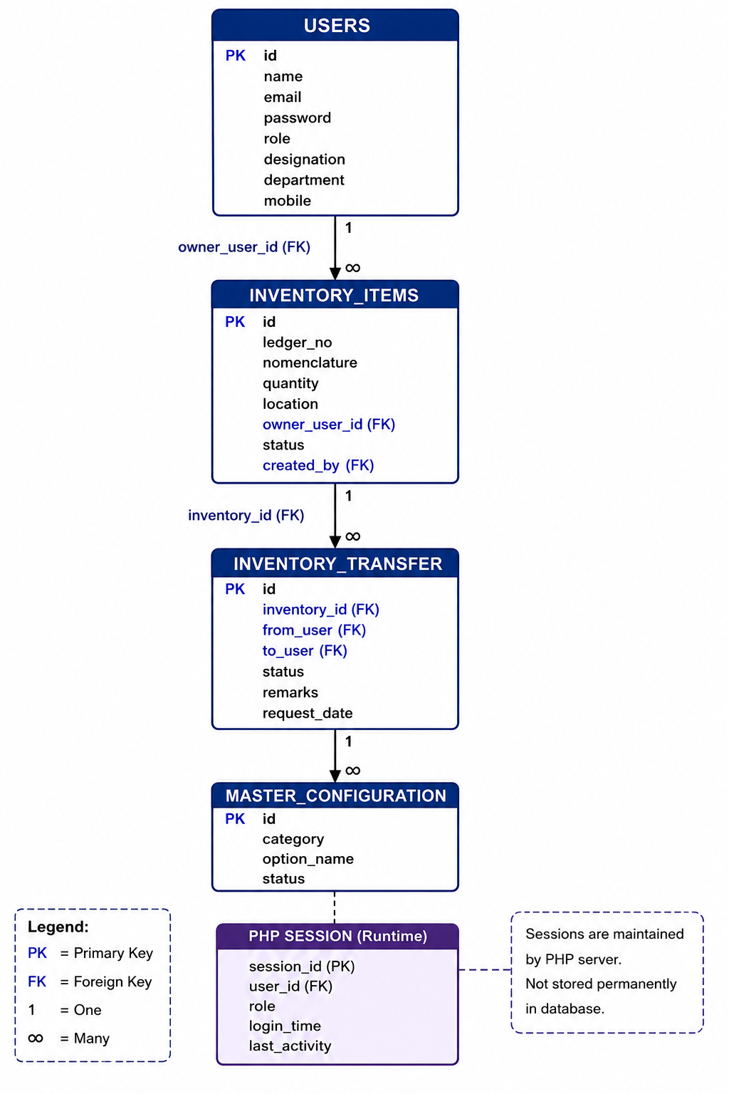
Figure 3.2: Entity Relationship Diagram of the Web Based Inventory Management System
Database Tables
The database consists of multiple relational tables that work together to support different functionalities of the application.
- Users Table
The Users table stores all information related to registered users of the application. Every person accessing the system must have an account stored within this table. The information maintained includes personal details, login credentials, and access privileges.
The table supports secure authentication and Role-Based Access Control (RBAC). Depending upon the assigned role, users receive different permissions within the application. Administrators have complete control over the system, while Inventory Heads and Normal Users receive restricted access according to organizational requirements.
Important Fields
- User ID
- Name
- Email
- Password
- Role
- Mobile Number
- Designation
- Department
- Created Date
Purpose
- User Authentication
- Login Validation
- Session Creation
- Role Management
- User Administration
- Inventory Items Table
The Inventory Items table serves as the core database table of the application. It stores detailed information regarding every hardware asset managed by the organization.
Each inventory record contains complete information regarding hardware specifications, ownership, location, department, status, and quantity. The table allows administrators to maintain organized inventory records and monitor asset utilization throughout the organization.
Important Fields
- Inventory ID
- Ledger Number
- Nomenclature
- Quantity
- Unit
- Location
- Owner
- Status
- Created By
- Created Date
Purpose
- Hardware Tracking
- Inventory Monitoring
- Asset Allocation
- Status Management
- Inventory Search
- Inventory Transfer Requests Table
The Inventory Transfer Requests table maintains all inventory movement requests generated within the application.
Whenever inventory is transferred from one employee or department to another, a request is generated and stored in this table. The request remains pending until reviewed by authorized personnel.
After approval, the inventory ownership is updated automatically. If rejected, the inventory remains assigned to the original owner.
Important Fields
- Request ID
- Inventory ID
- From User
- To User
- Request Date
- Approval Status
- Remarks
Purpose
- Inventory Transfer
- Approval Workflow
- Request History
- Audit Tracking
- Master Configuration Table
The Master Configuration table stores configurable options used throughout the application.
Instead of hardcoding values directly into the application, categories such as departments, designations, groups, locations, connectivity types, and other dropdown values are maintained dynamically inside this table.
Whenever administrators add a new department or designation, it becomes automatically available throughout the application without modifying source code.
Important Fields
- Configuration ID
- Category
- Option Name
- Status
Purpose
- Dynamic Configuration
- Department Management
- Designation Management
- Dropdown Management
- Centralized Configuration
- Session Management
Unlike the other entities, session information is not permanently stored inside the database. User sessions are maintained by the PHP server using Session Variables after successful authentication.
When a user logs into the application, PHP generates a unique session identifier and stores user information securely. The session remains active until the user logs out or the session expires.
Session management provides several security benefits including:
- User Authentication
- Secure Navigation
- Unauthorized Access Prevention
- Session Timeout
- Logout Management
Proper session handling ensures that only authenticated users can access protected application modules.
Relationships Between Tables
The database has been designed using relational database principles to establish meaningful connections among different entities. The database has been designed using relational database principles to establish meaningful connections among different entities.
The Users table has a one-to-many relationship with the Inventory Items table because one user can own multiple inventory assets.
Similarly, the Inventory Items table has a one-to-many relationship with the Inventory Transfer Requests table because one inventory item may undergo multiple transfer requests during its lifecycle.
The Master Configuration table operates independently and provides configurable values to multiple application modules through lookup operations.
These relationships maintain data consistency and eliminate unnecessary duplication of information.
Primary Keys
A Primary Key uniquely identifies every record within a database table.
The following primary keys are implemented:
Table | Primary Key
Users | id
Inventory Items | id
Inventory Transfer Requests | id
Master Configuration | id

Primary keys ensure uniqueness, improve indexing performance, and prevent duplicate records.
Foreign Keys
Foreign Keys establish relationships between different tables by referencing primary keys of related entities.
Examples include:
Table | Foreign Key | References
Inventory Items | owner_user_id | Users.id
Inventory Items | created_by | Users.id
Inventory Transfer Requests | inventory_id | Inventory Items.id
Inventory Transfer Requests | from_user | Users.id
Inventory Transfer Requests | to_user | Users.id

Foreign keys enforce referential integrity by ensuring that related records remain consistent throughout the database.
Advantages of the Database Design
The database architecture offers several advantages that improve the efficiency and reliability of the Inventory Management System.
- Centralized storage of all inventory-related information.
- Elimination of duplicate and inconsistent records through normalization.
- Secure management of user authentication and authorization.
- Efficient retrieval of inventory information using SQL queries.
- Flexible handling of inventory transfers and approval workflows.
- Dynamic configuration through the Master Configuration table.
- Scalable architecture that supports future enhancements.
- Improved data integrity using primary key and foreign key relationships.
- Better system performance due to optimized relational design.
The relational database structure provides a robust foundation for the Web Based Inventory Management System. It ensures accurate data management, secure access control, efficient retrieval of information, and reliable communication between different application modules. The well-organized database architecture also simplifies future maintenance and supports the addition of new features as organizational requirements evolve.

3.5 : Authentication Module
Authentication is one of the most important components of the Web Based Inventory Management System. It ensures that only authorized users can access the application and perform operations according to their assigned roles. The authentication mechanism developed during the internship provides secure user registration, login validation, password protection, session management, and logout functionality. It forms the first layer of security for the application and prevents unauthorized access to confidential inventory data.
The authentication module was developed using React (Vite) for the frontend, PHP for backend processing, and MySQL for storing user credentials. Communication between the frontend and backend is performed using REST APIs, while PHP sessions are used to maintain authenticated user sessions throughout the application.
User Registration
The registration module allows new users to create an account before accessing the system. The registration form collects the required personal and organizational information, including the user's name, gender, cadre, designation, group, email address, mobile number, telephone number, and password. This information is validated before being stored in the MySQL database.
Several validation mechanisms have been implemented to ensure data integrity. Mandatory fields cannot be left empty, email addresses must follow a valid format, and duplicate email IDs are not permitted. Password validation enforces minimum security requirements, including a minimum length and the use of special characters. These validations help prevent incorrect or incomplete data from being stored in the system.
After successful validation, the backend encrypts and stores the user credentials in the database. A confirmation message is displayed to the user, indicating that the registration process has been completed successfully. Newly registered users are assigned a default role, and administrative privileges can later be granted by the system administrator if required.
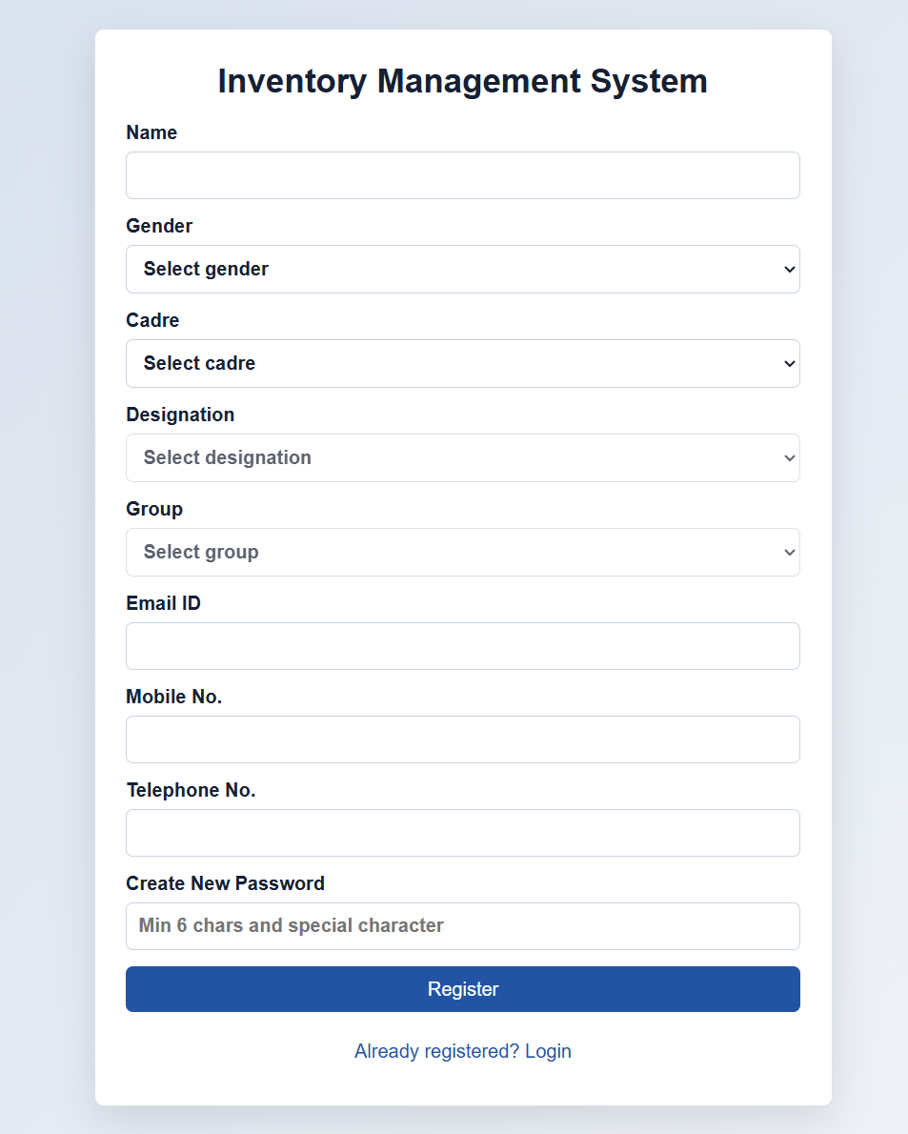
Figure 3.3: User Registration Interface
The above figure shows the user registration page of the Web Based Inventory Management System. The registration form allows new users to enter personal and organizational details such as name, email, designation, cadre, group, and contact information. Password validation and input verification ensure secure user registration before the information is stored in the database.
User Login
The login module authenticates registered users before granting access to the Inventory Management System. Users are required to enter their registered email address and password. These credentials are transmitted securely to the PHP backend through REST API requests.
The backend verifies the entered credentials against the records stored in the MySQL database. If the credentials are valid, a PHP session is created, and the user's role and profile information are loaded. Depending on the assigned role, the user is redirected to the appropriate dashboard.
If incorrect credentials are entered, the application displays an informative error message and denies access. This mechanism prevents unauthorized users from entering the system and protects confidential organizational information.
The login module also supports role-based authentication, ensuring that administrators, inventory heads, and normal users receive access only to their permitted functionalities.
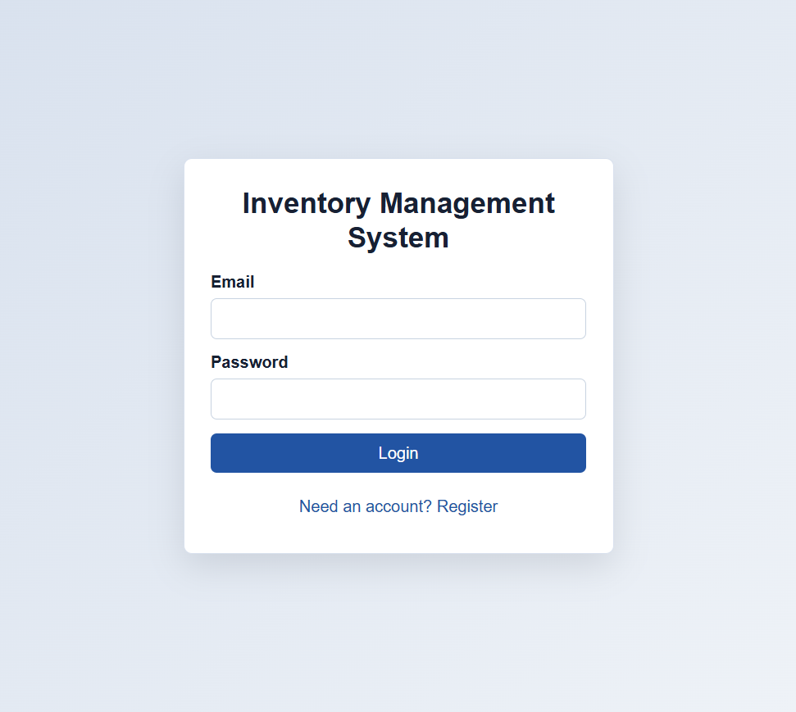
Figure 3.4: User Login Interface
The above figure illustrates the login interface of the Web Based Inventory Management System. Registered users can authenticate themselves using their email address and password. Upon successful verification, the system creates a secure session and redirects the user to the appropriate dashboard according to the assigned role.
Password Validation
Password security is an essential aspect of the authentication process. The system implements validation rules to ensure that users create strong passwords during registration and password updates. Passwords must satisfy predefined security requirements, including minimum length and complexity.
Before storing passwords in the database, they are encrypted using PHP's secure password hashing functions. During login, the entered password is compared with the stored encrypted password using secure verification methods. This approach ensures that actual passwords are never stored in plain text, thereby enhancing application security.
In addition to registration, users can also update their passwords through the profile module. The application verifies the current password before allowing a new password to be set. This prevents unauthorized password changes and protects user accounts from misuse.
Password validation reduces the risk of weak credentials, improves data protection, and strengthens the overall security of the application.
Session Management
Once a user successfully logs into the system, the backend creates a PHP session to maintain the authenticated state throughout the application. The session stores important information such as the user's ID, name, email address, and assigned role.
Instead of requesting login credentials on every page, the application checks whether a valid session already exists. If the session is active, the requested page is displayed; otherwise, the user is redirected to the login page.
Session management also supports role-based authorization by verifying the user's permissions before granting access to sensitive modules such as User Management, Master Configuration, and Inventory Administration. Unauthorized users are prevented from accessing restricted functionalities.
The use of PHP sessions improves both application security and user convenience by providing continuous authentication without repeated logins.
Logout Functionality
The logout feature enables users to securely terminate their active sessions after completing their work. When the Logout button is clicked, the PHP backend destroys the current session and removes all session variables stored on the server.
After the session is destroyed, the user is redirected to the login page. Any attempt to access protected pages without logging in again automatically redirects the user to the authentication screen. This mechanism prevents unauthorized access from shared or unattended computers and ensures that sensitive organizational information remains protected.
The logout process is simple yet essential for maintaining secure access control within the application.
Authentication Flow
The authentication workflow implemented in the application follows a structured sequence to ensure secure user access.
- A new user registers by entering personal and organizational information.
- The system validates all input fields and securely stores the user record in the MySQL database.
- The registered user enters their email address and password on the login page.
- The React frontend sends the login request to the PHP backend through a REST API.
- PHP verifies the credentials using the MySQL database.
- If authentication is successful, a secure PHP session is created.
- The user is redirected to the appropriate dashboard based on their assigned role.
- The session remains active until the user logs out or the session expires.
- During logout, the session is destroyed and the user is redirected to the login page.
Authentication Flow Diagram
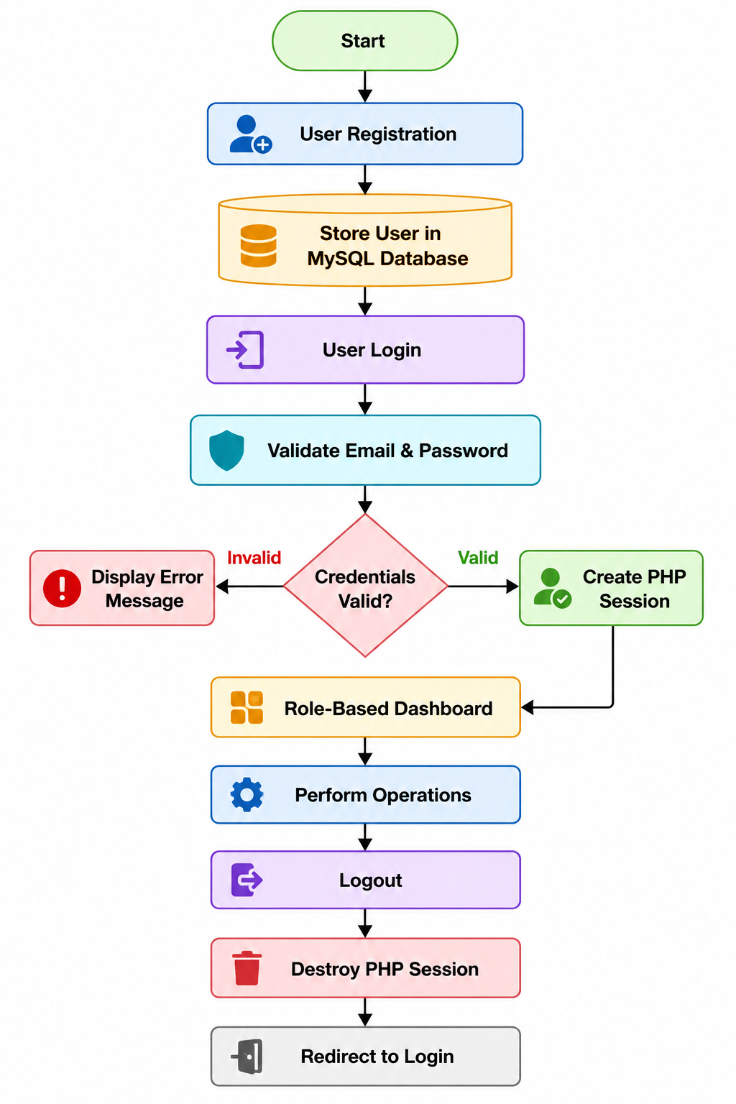
Figure 3.5: Authentication Flow of the Web Based Inventory Management System
Advantages of the Authentication Module
The authentication mechanism implemented in the Web Based Inventory Management System provides several benefits:
- Ensures secure user authentication before system access.
- Prevents unauthorized access through credential verification.
- Implements strong password validation and encryption.
- Maintains secure user sessions using PHP session management.
- Supports role-based access control for different categories of users.
- Protects sensitive inventory data through controlled authentication.
- Enables secure logout by destroying active sessions.
- Enhances the overall reliability, confidentiality, and security of the application.
This authentication module serves as the security foundation of the Web Based Inventory Management System, ensuring that only authorized personnel can access and manage organizational inventory data while maintaining confidentiality and integrity throughout the application.

3.6 : Inventory Module
The Inventory Module is the core component of the Web Based Inventory Management System, developed to facilitate efficient management of organizational assets. This module enables administrators and authorized personnel to add, update, search, transfer, print, and export inventory records through a centralized web interface. The objective of this module is to replace traditional paper-based inventory registers with a secure digital platform that provides quick access to inventory information and improves overall asset management.
The Inventory Module was developed using React (Vite) for the frontend, PHP for backend processing, and MySQL for data storage. The module communicates with the backend through REST APIs, allowing inventory data to be retrieved and updated dynamically without requiring page reloads. Since the application runs on a local XAMPP server, all operations are performed offline, ensuring data security within the organizational network.
Inventory Dashboard
The Inventory Dashboard serves as the central interface for managing inventory records. It provides users with a structured view of all available inventory items and supports various operations such as adding new inventory, modifying existing records, transferring assets, searching records, printing inventory details, and exporting data into CSV format.
The dashboard displays inventory information in a tabular format, making it easy to view and manage hardware assets. Search functionality and action buttons enable administrators to perform operations quickly and efficiently. The user-friendly interface improves accessibility while reducing the complexity of inventory management tasks.
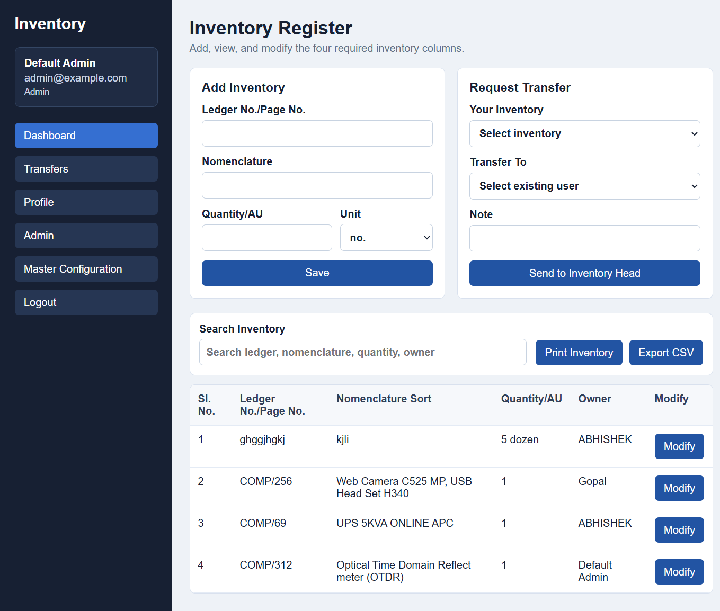
Figure 3.6: Inventory Management Dashboard
The above figure illustrates the Inventory Dashboard developed during the internship. The dashboard provides a centralized interface for managing inventory records. It supports inventory registration, asset search, ownership tracking, transfer requests, report generation, and inventory modification. The interface enables administrators to efficiently monitor and manage organizational assets through a simple and interactive web-based environment.
Add Inventory
The Add Inventory feature enables authorized users to register new inventory items within the system. Each inventory record includes essential information such as Ledger Number, Nomenclature, Quantity, Unit, Owner, and other related details. The system validates all mandatory fields before storing the information in the MySQL database.
When a new inventory item is added, the backend verifies the entered data and inserts the record into the database through secure SQL queries. This functionality eliminates manual record keeping and ensures that all inventory assets are maintained in a centralized database.
The inventory registration process is simple, efficient, and designed to minimize data entry errors.

Update Inventory
Inventory information often changes due to maintenance, relocation, ownership transfer, or quantity modifications. Therefore, the application provides an Update Inventory feature that allows authorized users to modify existing inventory records.
The update operation retrieves the selected inventory record from the database, displays its current information, and allows users to edit required fields. After validation, the modified data is saved back to the database using SQL UPDATE queries.
This feature ensures that inventory information remains accurate and reflects the latest organizational records.
Delete Inventory
The Inventory Module also provides functionality for removing unnecessary or obsolete inventory records. Administrators can delete inventory entries that are no longer required or have been entered incorrectly.
Before deleting a record, the application performs authorization checks to ensure that only users with appropriate administrative privileges can perform this operation. Confirmation messages are displayed before deletion to prevent accidental removal of important inventory data.
The Delete functionality helps maintain a clean and organized database by removing duplicate or outdated records.
Search Inventory
As the number of inventory records increases, locating specific assets manually becomes difficult. To address this challenge, the Inventory Module includes a Search Inventory feature.
Users can search inventory records using keywords such as:
- Ledger Number
- Nomenclature
- Quantity
- Owner Name
The search operation is performed dynamically, allowing users to retrieve matching records instantly without reloading the page. This feature significantly improves inventory accessibility and reduces the time required to locate hardware assets.
Efficient searching enhances productivity and enables faster inventory management operations.
Export Inventory (CSV)
To facilitate reporting and data sharing, the Inventory Module provides an Export CSV feature.
When this option is selected, all inventory records are converted into Comma-Separated Values (CSV) format and downloaded to the local system. The exported file can be opened using spreadsheet software such as Microsoft Excel for further analysis, documentation, or reporting purposes.
The Export CSV functionality reduces manual documentation efforts and simplifies inventory reporting for administrative purposes.
Print Inventory
The application also includes a Print Inventory feature that generates a printable version of inventory records.
Users can print inventory information directly from the dashboard without copying data into separate documents. The printed report maintains a structured layout suitable for organizational record keeping and verification.
This functionality is particularly useful during inventory audits, stock verification, and physical asset inspections.
Owner Management
Each inventory asset is assigned to a specific employee or department within the organization. The Owner field records the person responsible for the corresponding hardware asset.
Owner information enables administrators to determine asset accountability and simplifies inventory tracking across different departments. When ownership changes, the inventory transfer module updates the owner details automatically after successful approval.
Maintaining ownership records improves accountability and reduces the possibility of asset misplacement.
Quantity Management
The system records the quantity associated with each inventory item. Depending on the asset type, quantity may represent individual units or multiple items.
Quantity management helps administrators monitor stock availability, identify shortages, and maintain accurate inventory records. The application validates quantity values before storing them in the database to prevent incorrect inventory information.
Accurate quantity management supports better planning and resource allocation.
Ledger Number
Every inventory record is uniquely identified using a Ledger Number/Page Number. This identifier serves as the primary reference for locating inventory records within the organization.
The ledger number improves inventory organization by allowing assets to be traced easily during audits, inspections, or maintenance activities. Since every inventory item has a unique ledger reference, duplication of records is minimized.
This feature enhances record management and ensures efficient retrieval of inventory information whenever required.
Working of the Inventory Module
The Inventory Module follows a structured workflow for managing hardware assets:
- Authorized users log into the system.
- Users enter inventory details through the Add Inventory form.
- React sends the entered information to the PHP backend through REST APIs.
- PHP validates the data and stores it in the MySQL database.
- Inventory records are displayed dynamically on the dashboard.
- Users can search, modify, transfer, print, or export inventory records whenever required.
- All operations are reflected immediately on the dashboard through dynamic updates.
Advantages of the Inventory Module
The Inventory Management Module offers numerous benefits to the organization, including:
- Centralized management of inventory records.
- Faster registration and retrieval of hardware assets.
- Secure inventory modification through role-based authorization.
- Efficient searching using multiple criteria.
- Simplified inventory reporting through CSV export.
- Easy generation of printable inventory reports.
- Improved asset accountability through owner management.
- Accurate quantity monitoring and ledger-based tracking.
- Reduced paperwork and manual record maintenance.
- Enhanced data accuracy, security, and operational efficiency.
The Inventory Module forms the backbone of the Web Based Inventory Management System by providing a reliable, organized, and secure platform for managing organizational assets. Through features such as inventory registration, updating, searching, exporting, printing, and ownership tracking, the module significantly improves inventory control while supporting efficient day-to-day administrative operations.

3.7 : Transfer Request Module
The Transfer Request Module is an important component of the Web Based Inventory Management System that enables the controlled transfer of inventory assets between employees or departments. In many organizations, hardware assets such as computers, printers, networking devices, and laboratory equipment are frequently reassigned due to employee transfers, departmental requirements, or project allocations. Managing these transfers manually can lead to inaccurate records, loss of asset traceability, and unauthorized ownership changes.
To address these challenges, the Transfer Request Module was developed to provide a secure, transparent, and approval-based workflow for inventory movement. The module allows users to submit transfer requests, which are then reviewed by authorized personnel such as the Inventory Head or Administrator. Only after approval is the ownership of the inventory item updated in the system. This mechanism ensures proper accountability and maintains the integrity of inventory records.
The module was developed using React (Vite) for the frontend, PHP for backend processing, and MySQL for storing transfer request information. REST APIs are used to exchange data between the frontend and backend, while PHP sessions ensure that only authenticated users can submit or approve transfer requests.
Transfer Request Dashboard
The Transfer Request Dashboard provides a centralized interface for viewing and managing all inventory transfer requests. It displays detailed information regarding each request, including the inventory item, current owner, recipient, request submission time, approval time, status, and remarks.
Users can easily monitor the progress of transfer requests without requiring manual communication or paper-based documentation. Administrators and Inventory Heads can review pending requests and perform approval or rejection actions directly through the web interface.
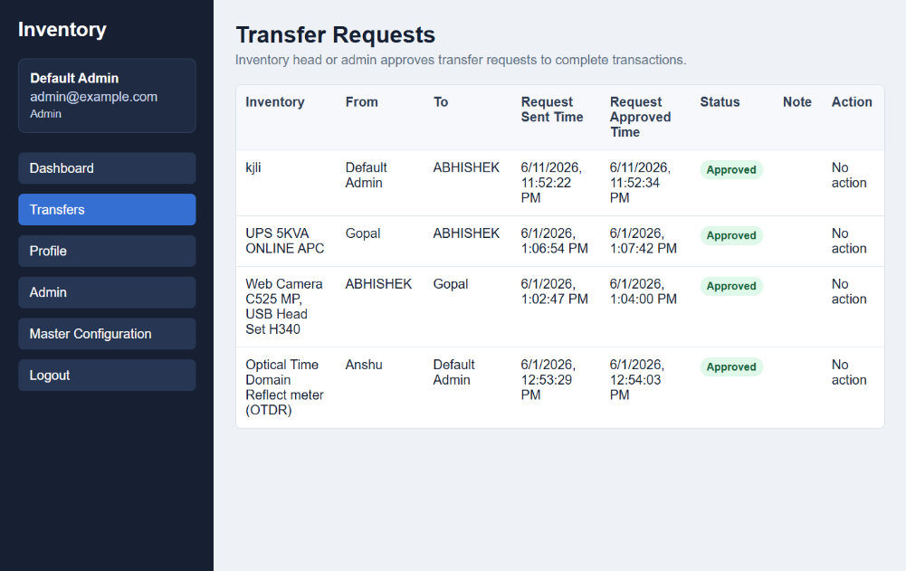
Figure 3.7: Inventory Transfer Request Module
The above figure illustrates the Transfer Request Module developed for the Web Based Inventory Management System. The module displays all inventory transfer requests along with details such as inventory item, sender, receiver, request submission time, approval time, status, and remarks. Authorized personnel can review each request and perform approval or rejection actions while maintaining complete transaction history.
Send Transfer Request
The first step in the transfer process is submitting a transfer request. When a user wishes to transfer an inventory item to another employee, the system provides a transfer request form where the user selects the inventory item, specifies the recipient, and enters optional remarks or notes explaining the reason for the transfer.
Before submitting the request, the application verifies that the selected inventory belongs to the requesting user and that the recipient exists in the system. After successful validation, the request is stored in the MySQL database with a Pending status. This ensures that no ownership changes occur until the request has been reviewed by an authorized approver.
The Send Transfer Request feature improves transparency by recording every transfer request within the system and eliminating informal or undocumented asset movements.
Pending Requests
After a transfer request is submitted, it is marked as Pending. Pending requests indicate that the request is awaiting review by the Inventory Head or Administrator.
The Pending status prevents immediate ownership changes and ensures that every inventory movement follows the organization's approval process. Administrators can review the request details, verify the legitimacy of the transfer, and decide whether to approve or reject the request.
Maintaining a pending state helps establish accountability and reduces the possibility of unauthorized inventory transfers.
Approved Requests
When an authorized administrator or Inventory Head approves a transfer request, the request status changes from Pending to Approved.
After approval, the system automatically updates the ownership information of the corresponding inventory item in the database. The inventory is reassigned to the new employee, and the transfer record is permanently stored for future reference.
The approval mechanism ensures that only verified and authorized transfers are executed, thereby maintaining accurate inventory ownership records throughout the organization.
Rejected Requests
If the administrator determines that a transfer request is invalid, incomplete, or violates organizational policies, the request is marked as Rejected.
Rejected requests do not modify the ownership of the inventory item. The inventory remains assigned to its original owner, and the rejection is recorded in the database. This provides a complete audit trail of all transfer requests, including unsuccessful ones.
The rejection process prevents unauthorized or unnecessary inventory movement and strengthens overall inventory control.
Notes and Remarks
Each transfer request allows users and administrators to include Notes or Remarks. These comments provide additional information regarding the purpose of the transfer, special instructions, or reasons for approval or rejection.
For example, notes may indicate that equipment is being transferred due to employee relocation, project reassignment, maintenance requirements, or departmental changes. Recording such information improves documentation and helps future administrators understand the history of each inventory transaction.
The Notes field enhances communication while maintaining a complete record of inventory movement within the organization.
Approval Time
The system automatically records the Approval Time whenever a transfer request is approved or rejected. This timestamp is stored in the database and displayed within the Transfer Request Dashboard.
Maintaining approval timestamps provides several benefits:
- Tracks when inventory ownership changes occurred.
- Supports inventory audits and verification.
- Improves accountability of approving authorities.
- Maintains a chronological history of inventory transactions.
- Assists in resolving future inventory-related disputes.
The automatic recording of approval time ensures that transfer records remain complete and accurate.
Transfer Workflow
The Transfer Request Module follows a structured approval workflow to ensure secure and controlled inventory movement.
The workflow begins when a user selects an inventory item and submits a transfer request to another employee. The request is stored in the database with a Pending status. Authorized personnel review the request, verify the transfer details, and either approve or reject it. If approved, the inventory ownership is updated automatically, and the approval time is recorded. If rejected, the inventory remains assigned to the original owner while the rejection status is maintained in the request history.
This workflow ensures that every inventory transfer is properly documented, authorized, and traceable.
Transfer Request Workflow
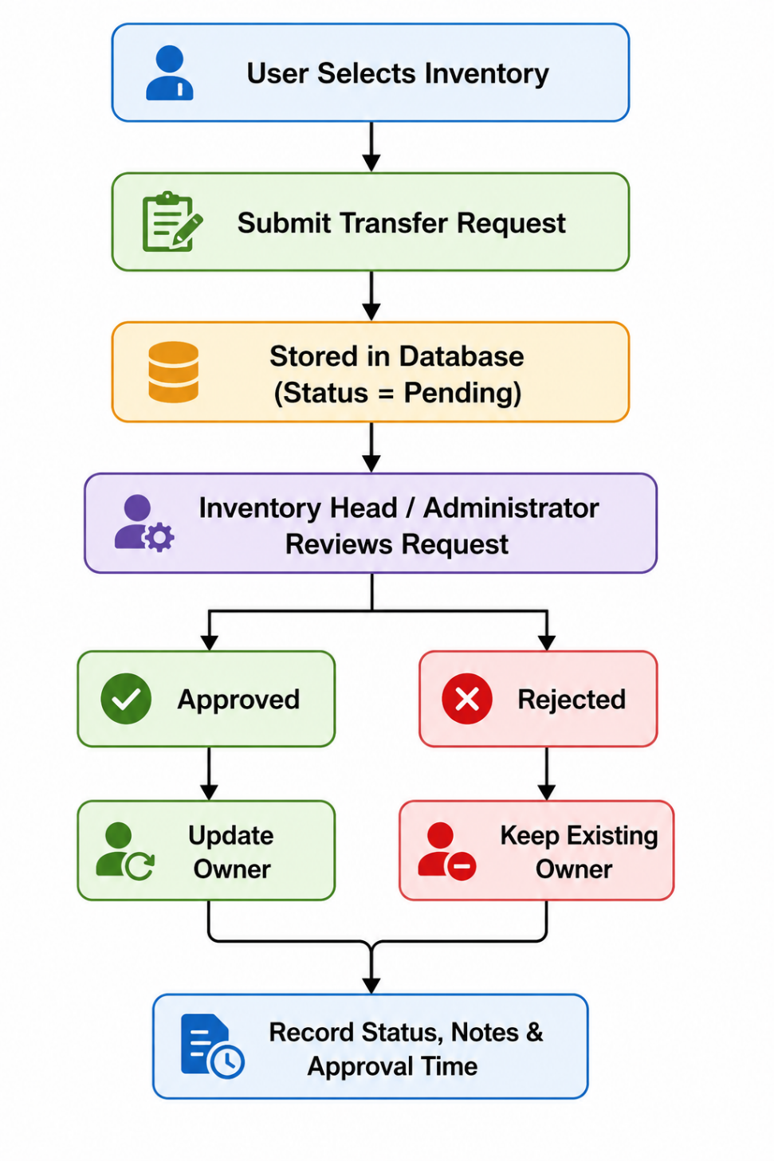
Figure 3.8: Workflow of the Inventory Transfer Request Module
Advantages of the Transfer Request Module
The Transfer Request Module offers several organizational benefits:
- Enables secure and approval-based inventory transfers.
- Prevents unauthorized ownership changes.
- Maintains complete transfer history for audit purposes.
- Records approval and rejection details automatically.
- Improves accountability through ownership tracking.
- Stores notes and remarks for better documentation.
- Supports transparent inventory movement across departments.
- Enhances data integrity by updating ownership only after approval.
- Reduces manual paperwork and simplifies asset transfer management.
Overall, the Transfer Request Module significantly improves inventory control by ensuring that every asset movement is authorized, documented, and traceable. Its approval-based workflow strengthens organizational security, maintains accurate ownership records, and provides a reliable audit trail for all inventory transfer activities.

3.8 : User Profile Module
The User Profile Module is an essential component of the Web Based Inventory Management System, designed to allow authenticated users to manage and update their personal information securely. In any enterprise application, user information such as designation, contact details, organizational role, and password may change over time. Therefore, providing users with the ability to update their own profile helps maintain accurate records while reducing the administrative workload.
The module was developed using React (Vite) for the frontend, PHP for server-side processing, and MySQL for storing user information. The module communicates with the backend through REST APIs, while authentication is maintained using PHP sessions. Only authenticated users can access their profile information, ensuring data privacy and security.
Profile Dashboard
The Profile Dashboard provides a dedicated interface where users can view and update their personal and organizational details. After successful login, users can access the Profile page from the navigation menu. The dashboard displays all editable fields in an organized form, allowing users to modify their information whenever required.
The interface is divided into two main sections:
- Update Profile
- Change Password
This separation improves usability by allowing users to manage profile information and password security independently.
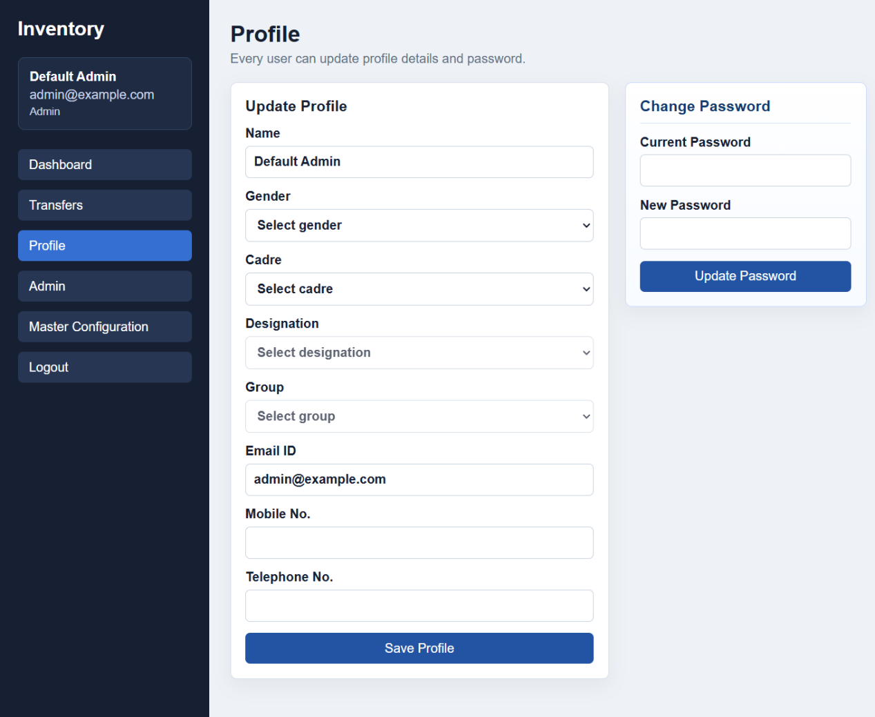
Figure 3.9: User Profile Management Module
The above figure illustrates the User Profile Module developed for the Web Based Inventory Management System. The module enables authenticated users to update personal information, organizational details, and contact information. It also provides a secure interface for changing account passwords while maintaining data integrity and user authentication.
Update Personal Details
One of the primary functions of the User Profile Module is updating personal information. Users can modify their profile whenever there is a change in their personal or organizational details.
The profile form includes information such as:
- Name
- Gender
- Email ID
- Mobile Number
- Telephone Number
- Designation
- Cadre
- Group
Whenever users update their profile, the application validates all mandatory fields before sending the data to the backend. PHP processes the request, verifies the session, and updates the corresponding user record in the MySQL database using SQL UPDATE queries.
This functionality ensures that employee information remains accurate and up to date throughout the system.
Password Change
The Profile Module also includes a secure Change Password feature. Password management is an important aspect of user account security because passwords may need to be updated periodically to prevent unauthorized access.
To change the password, users must enter:
- Current Password
- New Password
The application first verifies the current password against the encrypted password stored in the database. If verification is successful, the new password is validated according to predefined security rules and then securely stored using PHP password hashing functions.
If the entered current password is incorrect, the application displays an error message and prevents unauthorized password modification.
This mechanism protects user accounts while maintaining strong authentication standards.
Mobile Number Management
The Profile Module allows users to maintain their latest Mobile Number within the application. Mobile numbers serve as an important means of communication and identification inside the organization.
Whenever users change their contact number, they can update it directly from the Profile page without requiring administrator assistance.
Maintaining accurate mobile information improves communication between employees and supports future enhancements such as SMS notifications or mobile verification.
Designation Management
Every employee belongs to a particular Designation within the organization, such as Scientist, Technical Officer, Administrative Staff, or other authorized positions.
The designation field identifies the user's official position and helps determine organizational hierarchy. During profile updates, users can select the appropriate designation from predefined options configured in the Master Configuration Module.
Using predefined designations ensures consistency throughout the database and prevents duplicate or inconsistent records.
Cadre Information
The application also stores Cadre information for each employee. Cadre classification helps organize employees according to their organizational category or service group.
The Cadre field is linked with the Master Configuration Module, allowing administrators to define and manage available cadre options centrally. Users simply select the appropriate cadre from the available list instead of manually entering text.
This improves data accuracy and standardization across the application.
Group Information
In addition to designation and cadre, each user belongs to an organizational Group. Groups help classify employees according to departments, laboratories, or functional divisions.
The Group information assists administrators in organizing inventory ownership and simplifies reporting based on organizational structure.
Like Cadre and Designation, the Group values are dynamically loaded from the Master Configuration Module, ensuring consistency throughout the application.
Data Validation and Security
The User Profile Module incorporates multiple validation mechanisms to ensure secure and accurate profile management.
These include:
- Mandatory field validation
- Valid email format verification
- Mobile number validation
- Password strength verification
- Session authentication
- Role verification
- Server-side validation using PHP
Only authenticated users can modify their own profile information. Unauthorized users cannot access or update another employee's profile.
This multi-layer validation approach improves application security while maintaining database integrity.
Working of the User Profile Module
The workflow of the Profile Module follows a secure sequence of operations.
- The user logs into the application.
- The Profile page retrieves existing information from the MySQL database.
- The user edits personal or organizational details.
- React sends the updated information to the PHP backend through REST APIs.
- PHP validates the user session and verifies the entered data.
- The validated information is updated in the MySQL database.
- A success message is displayed after successful profile update.
- For password changes, the current password is verified before updating the new encrypted password.
User Profile Workflow
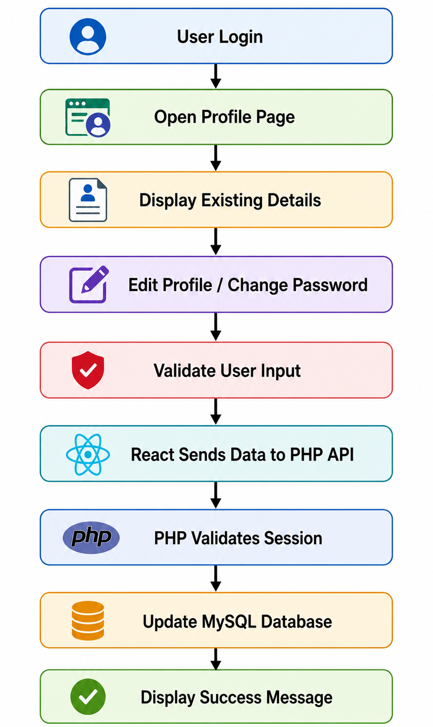
Figure 3.10: Workflow of the User Profile Module
Advantages of the User Profile Module
The User Profile Module provides several important benefits to the Inventory Management System:
- Enables users to update personal information independently.
- Maintains accurate employee records within the database.
- Provides secure password change functionality.
- Supports profile management through role-based authentication.
- Improves organizational data consistency using predefined Designation, Cadre, and Group values.
- Protects sensitive user information through session-based authentication.
- Reduces administrative workload by allowing self-service profile updates.
- Enhances security using server-side validation and encrypted password storage.
- Ensures reliable communication by maintaining updated contact information.
- Improves the overall usability, security, and maintainability of the Web Based Inventory Management System.
The User Profile Module contributes significantly to the application's security and user experience by allowing authenticated users to manage their personal and organizational information efficiently while ensuring that all updates are securely validated and stored in the database.

3.9 : Admin Module
The Admin Module is one of the most important components of the Web Based Inventory Management System. It provides centralized control over the application by enabling administrators to manage users, assign roles, and control access to different system functionalities. The module ensures that only authorized personnel can perform administrative operations, thereby maintaining the security, integrity, and reliability of inventory data.
The Admin Module was developed using React (Vite) for the frontend, PHP for backend processing, and MySQL for storing user and role information. Authentication is handled through PHP sessions, while role-based authorization determines the level of access available to each user after login. By implementing role-based access control, the system prevents unauthorized users from accessing sensitive administrative features and protects organizational data from accidental or intentional misuse.
Admin Dashboard
The Admin Dashboard provides administrators with a centralized interface for managing users and controlling access permissions. It displays all registered users in a tabular format along with details such as name, email address, mobile number, cadre, designation, group, and assigned role.
Administrators can view user information, modify user roles, and manage system permissions directly from this dashboard. The interface has been designed to simplify administrative tasks while ensuring that role changes are performed securely and efficiently.
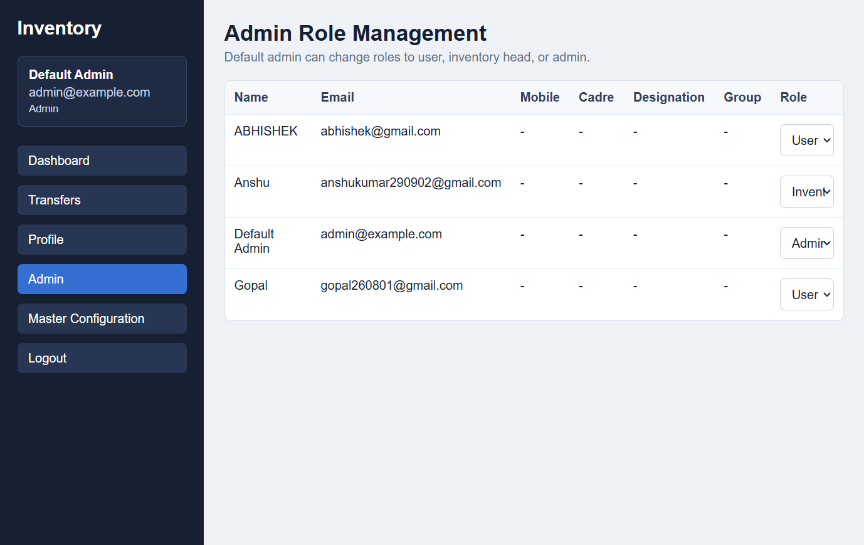
Figure 3.11: Admin Role Management Module
The above figure illustrates the Admin Module of the Web Based Inventory Management System. The module allows administrators to view registered users, assign appropriate roles, and control access to different application functionalities. Through this interface, administrators can efficiently manage user permissions while maintaining secure access to organizational resources.
Role- Based Access Control (RBAC)
The application implements Role-Based Access Control (RBAC) to ensure that every user accesses only those modules that are relevant to their responsibilities. Instead of granting identical permissions to every user, the system assigns specific privileges based on predefined roles.
After successful authentication, the PHP backend retrieves the user's assigned role from the MySQL database and stores it in the active session. The React frontend then dynamically displays menus and functionalities according to the authenticated user's role. This approach improves application security and prevents unauthorized access to confidential inventory data.
The implemented RBAC model simplifies user management while maintaining strict control over administrative operations.

Administrator Role
The Administrator possesses the highest level of authority within the application. Administrators are responsible for managing users, configuring system settings, supervising inventory operations, and maintaining overall system integrity.
Major responsibilities of the Administrator include:
- Managing registered user accounts.
- Assigning or modifying user roles.
- Accessing all inventory records.
- Managing master configuration data.
- Reviewing transfer requests.
- Monitoring inventory ownership.
- Updating organizational information.
- Maintaining system security.
Since administrators have unrestricted access to the application, role verification is performed before granting access to administrative modules.
Inventory Head Role
The Inventory Head acts as an intermediate administrative authority responsible for inventory-related operations. This role focuses on monitoring inventory movement, reviewing transfer requests, and maintaining accurate inventory records.
Users assigned the Inventory Head role can:
- View inventory records.
- Review transfer requests.
- Approve or reject inventory transfers.
- Monitor inventory ownership.
- Update inventory details.
- Generate inventory reports.
However, Inventory Heads cannot perform critical administrative functions such as assigning user roles or modifying organizational configuration unless additional permissions are granted.
This separation of responsibilities improves operational efficiency while maintaining administrative control.
User Role
The User role represents standard employees who utilize inventory resources within the organization. Users have limited access and can perform only authorized operations.
Typical user permissions include:
- Login to the application.
- View assigned inventory.
- Update personal profile.
- Submit transfer requests.
- Track request status.
- View inventory allocated to them.
Users cannot access administrative modules, modify system configuration, or change the roles of other users. Restricting these privileges helps maintain system security and prevents unauthorized modifications.
Role Change Functionality
One of the key features of the Admin Module is the Role Change functionality. Administrators can modify the role assigned to any registered user whenever organizational responsibilities change.
The available roles include:
- Administrator
- Inventory Head
- User
When a role is changed, the updated information is stored in the MySQL database. During the user's next login, the application retrieves the new role and automatically provides access to the corresponding modules.
This feature allows organizations to adapt quickly to changes in employee responsibilities without creating new user accounts.
Authorization Mechanism
Authorization is implemented after successful user authentication. Once a user logs into the application, PHP retrieves the assigned role from the database and stores it in the active session.
Before loading any protected page, the backend verifies:
- Whether the user session is active.
- Whether the requested module is permitted for the user's assigned role.
If the user attempts to access a restricted module without sufficient privileges, the request is denied and the application redirects the user to the appropriate page or displays an access denied message.
This multi-level authorization mechanism significantly enhances application security by ensuring that every operation is performed only by authorized personnel.
Working of the Admin Module
The Admin Module follows a secure workflow for managing user roles and permissions.
- The Administrator logs into the system.
- The application validates the administrator's credentials.
- The Admin Dashboard displays all registered users.
- The administrator selects a user account.
- A new role is selected from the available options.
- React sends the updated role information to the PHP backend through REST APIs.
- PHP validates the administrator's session and authorization.
- The new role is stored in the MySQL database.
- Updated permissions become effective during the user's next login session.
Admin Module Workflow
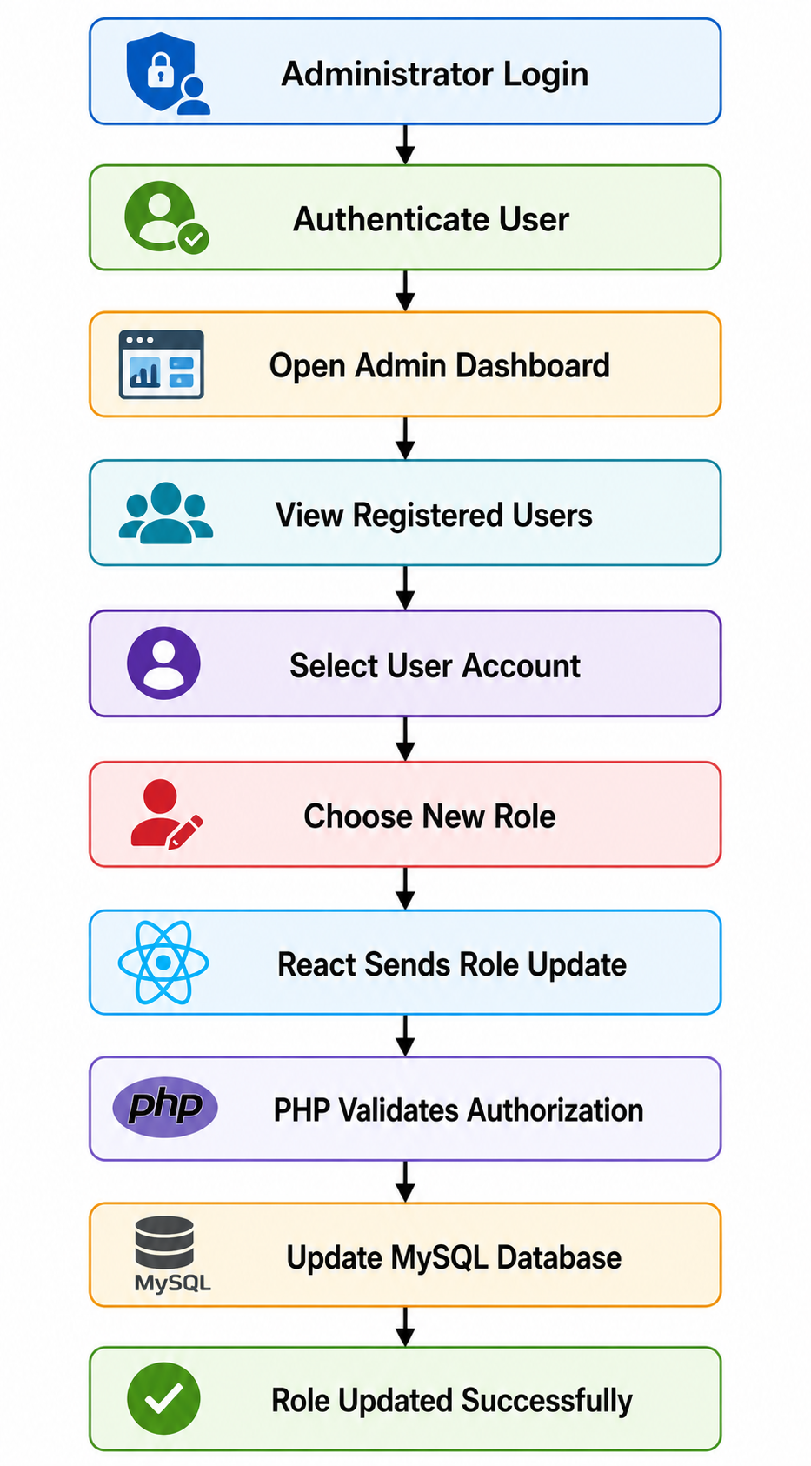
Figure 3.12: Workflow of the Admin Module
Advantages of the Admin Module
The Admin Module provides several important benefits to the Web Based Inventory Management System:
- Implements secure Role-Based Access Control (RBAC).
- Provides centralized user administration.
- Enables efficient management of user roles and permissions.
- Prevents unauthorized access to sensitive modules.
- Supports organizational hierarchy through Administrator, Inventory Head, and User roles.
- Enhances data security through server-side authorization.
- Simplifies system administration and user management.
- Maintains accountability by assigning permissions according to organizational responsibilities.
- Improves scalability by allowing easy addition or modification of user roles.
- Ensures secure and reliable operation of the inventory management system.
The Admin Module plays a vital role in maintaining the security and governance of the Web Based Inventory Management System. By implementing role-based access control, authorization checks, and centralized user management, it ensures that each user operates within their assigned responsibilities while protecting organizational data from unauthorized access or modification.

3.10 : Master Configuration Module
The Master Configuration Module is one of the most significant administrative components of the Web Based Inventory Management System. It provides a centralized platform for managing the master data used throughout the application. Instead of hardcoding organizational information such as cadre, designation, group, and status into the source code, this module stores the data in the database and allows administrators to manage it dynamically.
The module was developed using React (Vite) for the frontend, PHP for backend processing, and MySQL as the database. Through REST APIs, the frontend communicates with the backend to retrieve and update master configuration records. This dynamic approach improves flexibility, scalability, and maintainability while minimizing the need for code modifications whenever organizational data changes.
The Master Configuration Module ensures that all dropdown values displayed across the application are fetched directly from the database. As a result, administrators can easily add, modify, or deactivate configuration data without changing the application's source code.
Master Configuration Dashboard
The Master Configuration Dashboard serves as the centralized interface for managing all organizational master data. It enables administrators to create and maintain configuration records such as cadres, designations, groups, and their corresponding status.
The dashboard displays separate sections for each master category, allowing administrators to add new records, modify existing values, and manage their availability within the application. This organized interface simplifies configuration management while ensuring consistency throughout the Inventory Management System.
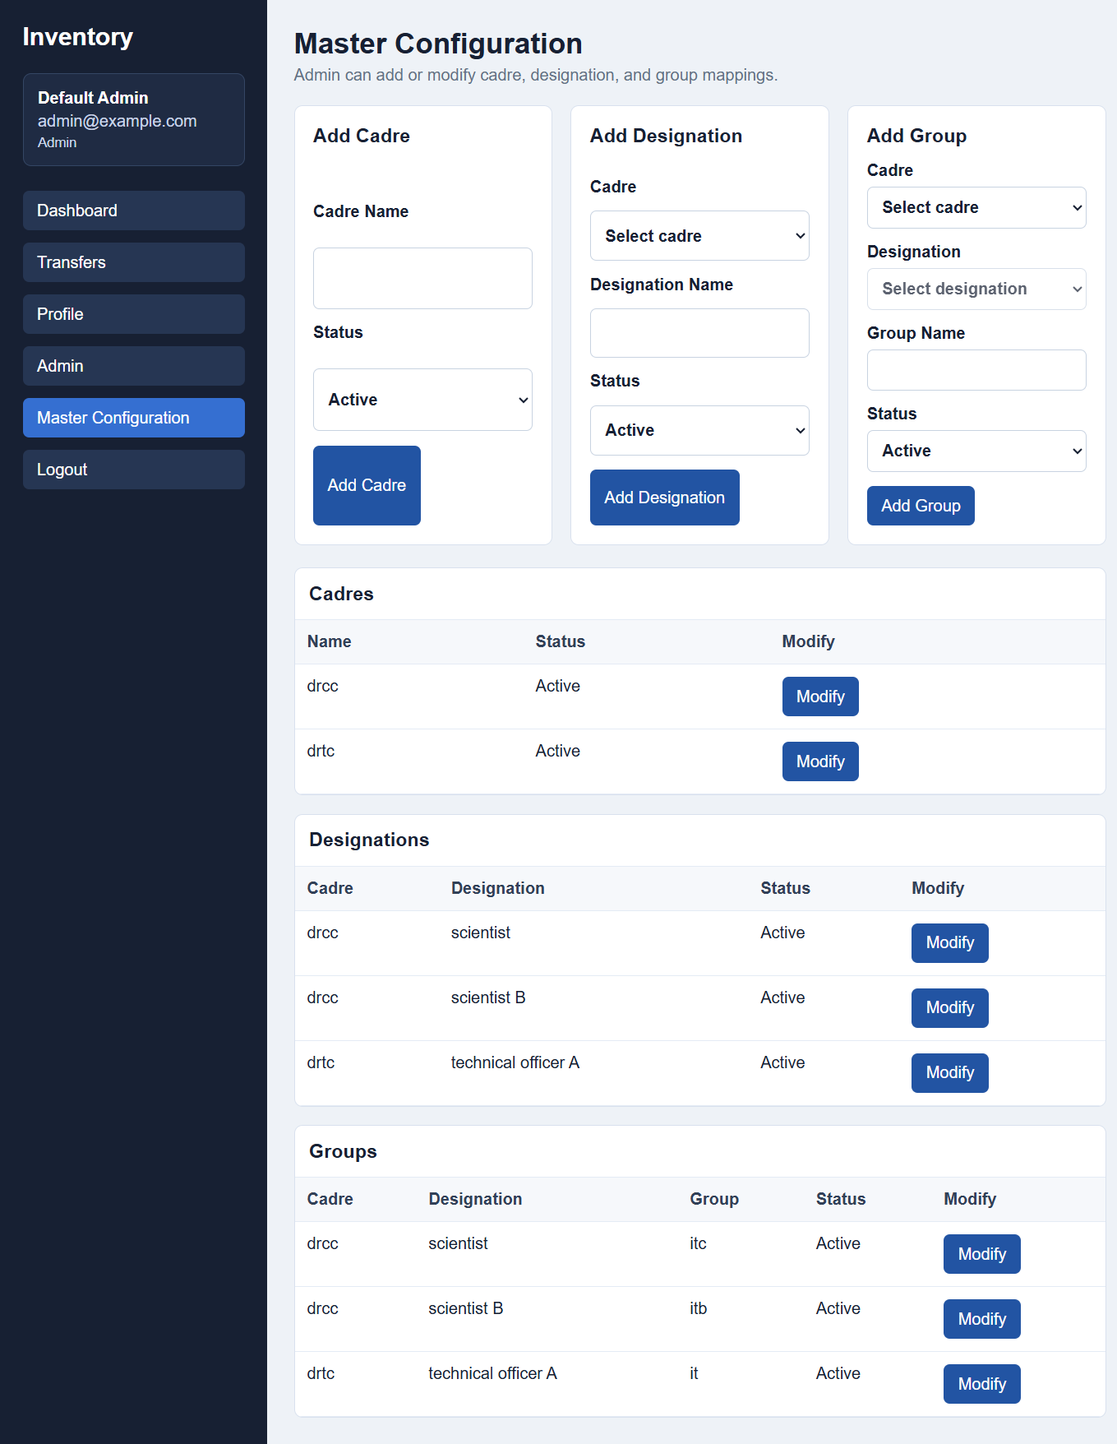
Figure 3.13: Master Configuration Module
The above figure illustrates the Master Configuration Module of the Web Based Inventory Management System. The interface allows administrators to manage organizational master data such as cadre, designation, group, and status. All configuration values are stored in the MySQL database and are dynamically loaded into different modules of the application, ensuring consistency and easy maintenance.
Cadre Management
The Cadre section allows administrators to create and manage different organizational cadres. A cadre represents the category or service classification of employees working within the organization.
Administrators can add new cadre names, update existing records, and activate or deactivate cadres according to organizational requirements. Once a cadre is created, it becomes available throughout the application, particularly in the Registration Module and User Profile Module.
The use of centralized cadre management eliminates duplicate entries and ensures that standardized organizational categories are maintained throughout the system.
Designation Management
The Designation section is used to manage official employee designations within the organization. Every designation is associated with a specific cadre, allowing the system to maintain a structured organizational hierarchy.
Administrators can create new designations, modify existing ones, or update their status. During user registration and profile updates, available designations are automatically loaded from the database according to the selected cadre.
This dynamic relationship between cadre and designation improves data consistency and reduces manual errors while entering employee information.
Group Management
The Group section manages organizational groups associated with specific designations. A group represents the functional division or administrative unit within the organization.
After selecting a cadre and designation, administrators can define the corresponding group. Users selecting a particular designation during registration or profile updates are presented only with the relevant group options.
Maintaining group information through the Master Configuration Module improves the logical organization of employee records and supports accurate classification throughout the Inventory Management System.
Status Management
Each master configuration record includes a Status field that determines whether the configuration is active or inactive.
The status functionality enables administrators to control the availability of configuration values without deleting them permanently. If a designation, cadre, or group is no longer required, it can simply be marked as inactive. Inactive records are excluded from application dropdown lists but remain stored in the database for future reference.
This approach preserves historical data while providing administrators with flexibility in managing organizational changes.
Dynamic Data Management
One of the most important features of this module is Dynamic Data Management. Instead of storing configuration values directly in the application source code, all master records are maintained inside the MySQL database.
Whenever administrators add or update configuration data, the changes become immediately available throughout the application without requiring any modifications to the frontend or backend code.
This dynamic architecture provides several advantages:
- Easy maintenance
- Centralized data management
- Reduced coding effort
- Improved scalability
- Better consistency across all modules
The use of dynamic master data makes the Inventory Management System adaptable to future organizational requirements.
Database-Driven Dropdown Lists
The Registration Module, User Profile Module, and other sections of the application utilize database-driven dropdown menus.
When a page is loaded, the React frontend sends an API request to the PHP backend. PHP retrieves the latest active configuration values from the MySQL database and returns them to the frontend. React then dynamically populates the dropdown menus.
For example:
- Selecting a Cadre loads the related Designation options.
- Selecting a Designation loads the corresponding Group options.
This dynamic loading mechanism ensures that users always view updated organizational information without requiring application redeployment.
Database-driven dropdowns improve user experience while eliminating inconsistencies caused by manually entered values.

Working of the Master Configuration Module
The Master Configuration Module follows a structured workflow to manage organizational configuration data.
- The Administrator logs into the system.
- The Master Configuration page is opened.
- The administrator selects the configuration category (Cadre, Designation, or Group).
- New values or modifications are entered through the interface.
- React sends the configuration data to the PHP backend using REST APIs.
- PHP validates the administrator's authorization.
- Valid data is stored or updated in the MySQL database.
- Whenever users access registration or profile pages, React automatically loads the latest active configuration values from the database.
Master Configuration Workflow
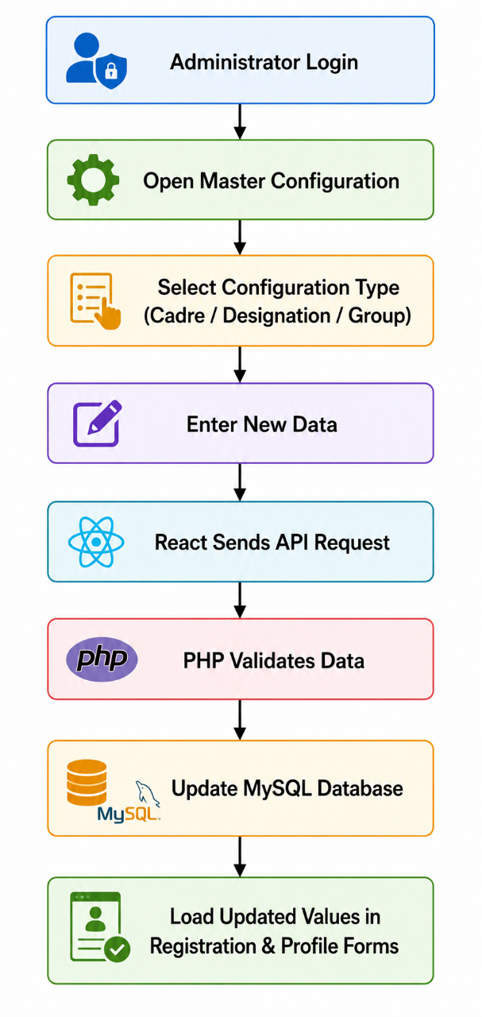
Figure 3.14: Workflow of the Master Configuration Module
Advantages of the Master Configuration Module
The Master Configuration Module provides several important benefits to the Web Based Inventory Management System:
- Centralized management of organizational master data.
- Eliminates hardcoded values from the application.
- Supports dynamic addition and modification of configuration records.
- Automatically updates dropdown lists throughout the application.
- Maintains consistency in cadre, designation, and group information.
- Improves scalability and simplifies future enhancements.
- Reduces maintenance effort by allowing administrators to manage configuration through the user interface.
- Preserves historical records using active and inactive status management.
- Enhances data integrity by ensuring standardized organizational information.
- Improves the flexibility, maintainability, and overall efficiency of the Inventory Management System.
The Master Configuration Module acts as the foundation for maintaining standardized organizational data across the application. By implementing database-driven configuration management, it eliminates repetitive coding, simplifies administrative tasks, and ensures that all modules use accurate and consistent information. This approach significantly enhances the scalability and maintainability of the Web Based Inventory Management System while supporting future organizational growth.

3.11 : API Integration
Application Programming Interface (API) Integration is one of the most important components of the Web Based Inventory Management System. The application follows a client-server architecture where the frontend and backend operate independently and communicate through REST APIs. This architecture allows the React frontend to request data from the PHP backend and receive responses in JSON format. The backend processes these requests, performs database operations using MySQL, and returns the required information to the frontend.
The project was developed using React (Vite) as the frontend framework, PHP for server-side programming, and MySQL as the relational database management system. The frontend uses the JavaScript Fetch API to send HTTP requests such as GET, POST, PUT, and DELETE to the backend. PHP receives these requests, validates user sessions and input data, performs the required SQL operations, and generates JSON responses. React then processes these responses and dynamically updates the user interface without reloading the entire page.
The use of REST API integration separates the presentation layer from the business logic, making the application more modular, maintainable, and scalable. This approach also simplifies debugging, testing, and future enhancements.
React Frontend
The frontend of the Inventory Management System was developed using React (Vite). React is responsible for displaying the graphical user interface and handling user interactions such as login, registration, inventory management, transfer requests, profile updates, and administrative operations.
Whenever a user performs an action—for example, clicking the Login, Save Inventory, or Update Profile button—the React component collects the entered information and sends it to the PHP backend using the JavaScript Fetch API.
React also processes the JSON responses received from the server and updates the displayed information dynamically without refreshing the page. This improves application responsiveness and provides a smooth user experience.
Fetch API
The Fetch API is the communication bridge between the React frontend and the PHP backend. It is a built-in JavaScript interface used for making asynchronous HTTP requests.
The application uses the Fetch API to perform operations such as:
- User Login
- User Registration
- Fetch Inventory Records
- Add Inventory
- Update Inventory
- Delete Inventory
- Transfer Requests
- Update User Profile
- Role Management
- Master Configuration Management
Each request is sent to the appropriate PHP API endpoint. The request contains user input encoded in JSON format or form data. After processing the request, the backend returns a JSON response that contains either the requested data or an appropriate success or error message.
The asynchronous nature of the Fetch API allows the application to continue functioning while waiting for server responses, thereby improving performance and user experience.
PHP Backend
The PHP backend serves as the business logic layer of the application. It receives requests from the React frontend, validates the input, verifies user sessions, performs database operations, and returns responses to the client.
The backend is responsible for:
- User authentication
- Session management
- Password verification
- Inventory management
- Transfer approval
- User administration
- Master configuration management
- Profile updates
PHP executes SQL queries on the MySQL database using secure database connectivity methods. Input validation and authorization checks are performed before any database operation to maintain data integrity and system security.
After completing the requested operation, PHP generates a structured JSON response containing status information, messages, and data required by the frontend.
MySQL Database
The MySQL database acts as the permanent storage layer of the application. All organizational information is stored in relational database tables.
Major database tables include:
- users
- inventory_items
- inventory_transfer
- master_configuration
- sessions
The PHP backend communicates with MySQL by executing SQL statements such as:
- SELECT
- INSERT
- UPDATE
- DELETE
These queries retrieve, store, modify, or remove application data according to the user's request. The database ensures consistency, reliability, and secure storage of inventory information.
JSON Response
After processing every API request, the backend returns a JSON (JavaScript Object Notation) response to the React frontend.
JSON is lightweight, easy to read, and ideal for communication between web applications.
A typical JSON response contains:
- Status
- Success/Error Message
- Requested Data
For example, after a successful login, PHP returns user information along with the authentication status. React processes this response and redirects the user to the appropriate dashboard according to the assigned role.
Similarly, inventory APIs return lists of inventory records in JSON format, which React displays dynamically inside tables.
The use of JSON improves interoperability between frontend and backend while simplifying data exchange.
API Communication Flow
Whenever a user performs an operation, the following sequence of events takes place:
- The user interacts with the React interface.
- React collects the required information.
- The Fetch API sends an HTTP request to the appropriate PHP endpoint.
- PHP validates the request and verifies the user's session.
- PHP executes SQL queries on the MySQL database.
- The database returns the requested information.
- PHP converts the result into JSON format.
- React receives the JSON response.
- The user interface is updated dynamically without reloading the page.
This structured communication ensures efficient and reliable data exchange throughout the application.

API Integration Flow Diagram
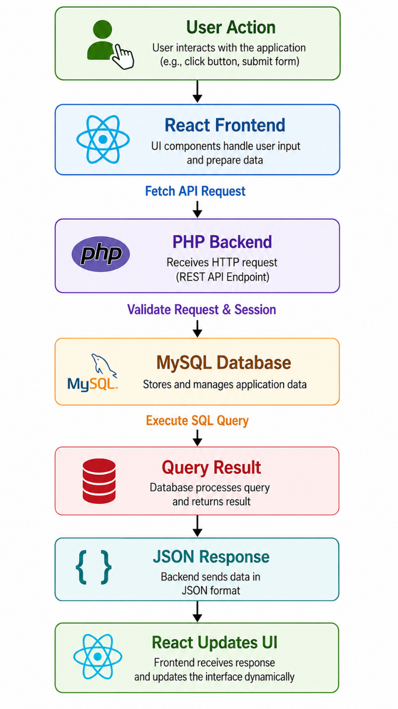
Figure 3.15: API Integration Flow of the Web Based Inventory Management System
Sample API Flow
The following example demonstrates the API communication process when a user adds a new inventory item.
Step 1: The user fills in the inventory details on the React interface.
Step 2: React collects the entered information and sends it to the PHP API using the Fetch API.
POST /api/inventory.php
Step 3: PHP validates the request, checks the active user session, and verifies the entered data.
Step 4: PHP inserts the inventory record into the MySQL database using an SQL INSERT query.
Step 5: The database confirms successful insertion.
Step 6: PHP generates a JSON response indicating successful completion.
Example JSON response:
{
“success”: true,
“message”: “Inventory item added successfully.”
}
Step 7: React receives the JSON response and immediately updates the inventory table displayed on the dashboard without requiring a page refresh.
Advantages of API Integration
The API integration implemented in the Web Based Inventory Management System provides several important advantages:
- Enables seamless communication between frontend and backend.
- Improves application performance and responsiveness.
- Simplifies frontend and backend maintenance through modular architecture.
- Enhances scalability by separating presentation and business logic.
- Provides standardized communication using JSON.
- Facilitates secure data validation and authorization through PHP.
- Simplifies future integration with other applications or services.
- Improves code reusability and maintainability.
- Supports efficient development of modern enterprise web applications.
The API integration architecture forms the backbone of the Web Based Inventory Management System. By combining React, the Fetch API, PHP, MySQL, and JSON, the application achieves efficient communication, secure data processing, and dynamic user interaction, making the system reliable, scalable, and suitable for real-world organizational use.

3.12 : Testing
Testing is an essential phase of software development that ensures the application performs correctly, securely, and reliably under different conditions. After completing the development of the Web Based Inventory Management System, extensive testing was carried out to verify that every module functioned according to the project requirements.
The objective of testing was to identify and eliminate functional errors, validate user inputs, verify database operations, and ensure seamless communication between the React frontend, PHP backend, and MySQL database. Different testing techniques were applied to confirm that the system behaved correctly during normal operations as well as when invalid or unexpected inputs were provided.
The major testing activities performed during the development of the project are described below.
Login Testing
- The Login Module was tested to verify that only authorized users could access the system. Login with valid email and password.

Different test scenarios were executed to ensure proper authentication.
The following conditions were verified:
- Login with valid email and password.
- Login using invalid credentials.
- Empty email field.
- Empty password field.
- Incorrect password.
- Unauthorized access to protected pages.
- Logout functionality.
- Session expiration.
When valid credentials were entered, the system successfully authenticated the user and redirected them to the appropriate dashboard according to their assigned role. Invalid credentials generated appropriate error messages, preventing unauthorized access.
Session testing confirmed that users could not access secured pages after logging out.
Login Testing Results
Test Case | Expected Result | Status
Valid Login | User redirected to dashboard | Passed
Invalid Password | Error message displayed | Passed
Empty Fields | Validation message shown | Passed
Logout | Session destroyed successfully | Passed

Registration Testing
The Registration Module was tested to ensure that new users could create accounts successfully while maintaining data integrity.
The following validations were performed:
- Mandatory field verification.
- Email format validation.
- Password length validation.
- Duplicate email checking.
- Mobile number validation.
- Required organizational fields.
The application successfully prevented duplicate registrations by verifying existing email addresses in the database. Password validation ensured that users entered strong passwords according to predefined security rules.
Only valid information was stored in the MySQL database.
Registration Testing Results
Test Case | Expected Result | Status
New User Registration | Account created successfully | Passed
Duplicate Email | Registration blocked | Passed
Invalid Email Format | Validation displayed | Passed
Weak Password | Error generated | Passed

CRUD Operation Testing
CRUD (Create, Read, Update, Delete) operations form the core functionality of the Inventory Management System.
Each database operation was individually tested to verify proper execution.
Create
New inventory records were added using the Inventory Dashboard.
The system verified all required fields before inserting the record into the MySQL database.

Read
Existing inventory records were retrieved from the database and displayed correctly inside the dashboard.
Search and filtering operations were also verified.
Update
Inventory information such as owner, quantity, location, and status was modified successfully.
Updated records immediately appeared in the inventory table.
Delete
Selected inventory records were deleted after administrator confirmation.
The deleted data no longer appeared in inventory listings.
CRUD Testing Results
Operation | Expected Result | Status
Create | Record inserted | Passed
Read | Data displayed correctly | Passed
Update | Record modified successfully | Passed
Delete | Record removed successfully | Passed

Input Validation Testing
Input validation was implemented on both the frontend and backend.
Frontend validation using React prevented users from submitting incomplete forms, while backend validation using PHP ensured that invalid or malicious data could not reach the database.
The following validations were tested:
- Empty fields.
- Invalid email addresses.
- Special characters.
- Numeric validation.
- Password validation.
- Required dropdown selection.
- Maximum input length.
All invalid inputs generated appropriate validation messages, preventing incorrect data from being stored.
This improved application security and maintained database consistency.
Validation Testing Results
Validation | Result | Status
Required Fields | Working | Passed
Email Validation | Working | Passed
Password Validation | Working | Passed
Numeric Validation | Working | Passed
Dropdown Validation | Working | Passed

Transfer Request Testing
The Transfer Request Module was tested to verify the inventory transfer workflow.
Different scenarios were executed:
- Submit transfer request.
- Approve request.
- Reject request.
- Display approval status.
- Store approval time.
- Update inventory ownership.
After users submitted transfer requests, the requests appeared in the administrator dashboard with Pending status.
Administrators successfully approved or rejected requests.
Approved transfers updated the inventory owner information automatically, while rejected requests preserved the original ownership.
Approval date, remarks, and status were correctly stored in the MySQL database.

Transfer Module Testing Results
Test Case | Expected Result | Status
Submit Request | Pending status created | Passed
Approve Request | Owner updated | Passed
Reject Request | Owner unchanged | Passed
Status Display | Correct status shown | Passed

Database Testing
Database testing verified that MySQL stored and retrieved data correctly.
The following database operations were tested:
- INSERT
- SELECT
- UPDATE
- DELETE
Relationships between tables were also verified.
The following database tables were tested:
- users
- inventory_items
- inventory_transfer
- master_configuration
Foreign key relationships and data consistency were maintained successfully.
No duplicate primary keys were generated during testing.
Database transactions executed correctly without data corruption.

Database Testing Results
Database Operation | Result | Status
INSERT | Successful | Passed
SELECT | Successful | Passed
UPDATE | Successful | Passed
DELETE | Successful | Passed

Browser Compatibility Testing
The application was tested on different web browsers to verify consistent performance.
The following browsers were used:
- Google Chrome
- Microsoft Edge
- Mozilla Firefox
The following aspects were verified:
- User Interface Layout
- Form Submission
- Navigation
- API Communication
- Dashboard Rendering
- Session Management
The application functioned correctly across supported browsers without major compatibility issues.
Google Chrome provided the best development and debugging environment because of its integrated Developer Tools.

Browser Testing Results
Browser | Result | Status
Google Chrome | Fully Functional | Passed
Microsoft Edge | Fully Functional | Passed
Mozilla Firefox | Functional | Passed

Overall Testing Summary
Comprehensive testing confirmed that the Web Based Inventory Management System performs reliably under different operating conditions. Authentication, registration, inventory management, transfer requests, user administration, and master configuration modules were tested thoroughly and produced the expected outcomes. Input validation successfully prevented invalid data entry, while database testing ensured accurate storage and retrieval of information.
The integration between the React frontend, PHP backend, and MySQL database functioned smoothly through REST APIs, providing real-time communication and dynamic updates. Browser compatibility testing verified that the application maintained a consistent user experience across major web browsers.
Overall, the testing process demonstrated that the system is stable, secure, and capable of supporting day-to-day inventory management operations within an organizational environment. The successful completion of all major test cases confirms that the developed application meets the functional requirements of the project and is suitable for deployment in a controlled local network environment without requiring an active internet connection.

3.13 : Challenges Faced
During the development of the Web Based Inventory Management System, several technical and implementation challenges were encountered. Since the project was developed using React (Vite) as the frontend, PHP as the backend, and MySQL as the database, integrating these technologies into a single working application required careful planning, continuous debugging, and systematic problem-solving. Each challenge provided valuable learning opportunities and helped improve both technical knowledge and software development skills. The major challenges faced during the internship and their corresponding solutions are discussed below.

React-PHP Integration
One of the primary challenges was integrating the React frontend with the PHP backend. React is a modern JavaScript framework that communicates with the server through REST APIs, whereas PHP traditionally renders server-side pages. Establishing smooth communication between these two technologies required proper API development and data exchange mechanisms.
Initially, requests sent from React were not correctly received by the PHP scripts because of incorrect API endpoints and request formatting. Different HTTP methods and request headers had to be configured properly to enable successful communication.
To overcome this issue, REST APIs were developed in PHP, and the Fetch API was used in React to send HTTP requests and receive JSON responses. Proper endpoint organization and structured API responses ensured reliable communication between the frontend and backend.
Cross- Origin Resources Sharing(CORS)
Another challenge encountered during development was related to Cross-Origin Resource Sharing (CORS). Since the frontend and backend were executed from different development environments during testing, browsers blocked API requests due to security restrictions.
This resulted in errors while attempting to access backend resources from the React application.
The issue was resolved by configuring appropriate CORS headers in the PHP backend, allowing requests from the authorized frontend origin. After enabling the required HTTP headers, React successfully communicated with the backend without browser restrictions.
Understanding CORS policies improved knowledge of web security and cross-origin communication.
MySQL Database Connection
Establishing a stable connection between PHP and the MySQL database was another significant challenge. Incorrect database credentials, server configuration issues, or unavailable database services occasionally prevented successful database access.
Proper configuration of the database connection file, verification of server status through XAMPP, and careful management of database credentials resolved these issues. Additional error handling mechanisms were implemented to display meaningful error messages whenever database connectivity problems occurred.
This experience strengthened understanding of database configuration and server management.

API Errors
Several API-related errors were encountered while implementing different modules of the application. Missing parameters, incorrect request methods, invalid JSON formatting, and unexpected server responses occasionally caused communication failures between the frontend and backend.
To identify these issues, browser Developer Tools and Network monitoring features were extensively used. API requests and responses were carefully inspected to verify request headers, payloads, status codes, and returned JSON data.
Systematic debugging and proper validation of request parameters significantly improved API reliability and overall application performance.
Session Handling
Maintaining user authentication throughout the application was another important challenge. The system required authenticated users to remain logged in while accessing protected modules such as inventory management, user administration, and transfer requests.
Initially, session information was not consistently maintained across different API requests, resulting in unauthorized access errors and unexpected user logouts.
The issue was resolved by implementing PHP session management correctly and validating active sessions before processing every protected request. Proper session destruction during logout also ensured secure termination of user authentication.
This improved both application security and user experience.
Debugging
Debugging became an integral part of the software development process throughout the internship. Errors related to React components, PHP scripts, SQL queries, API communication, and frontend rendering required continuous analysis and troubleshooting.
Different debugging techniques were applied, including:
- Browser Developer Tools
- Console logging
- PHP error reporting
- SQL query verification
- Network request inspection
Each identified issue was analyzed systematically until the root cause was determined and corrected. This process significantly improved logical thinking and software troubleshooting skills.

Form Validation
Ensuring accurate user input was another challenge during application development. Users could unintentionally enter incomplete or invalid information, leading to inconsistent database records.
Both frontend and backend validation mechanisms were implemented to address this issue.
Frontend validation using React prevented users from submitting incomplete forms, while PHP performed server-side validation before processing any request.
Validation rules included:
- Mandatory field verification
- Email format validation
- Password strength verification
- Numeric validation
- Required dropdown selection
- Input length restrictions
These validation mechanisms improved data accuracy and prevented invalid information from being stored in the database.
Duplicate Records
Duplicate data entry posed another challenge, particularly during user registration and inventory management.
Without proper verification, duplicate email addresses or repeated inventory records could compromise database integrity.
To solve this problem, uniqueness checks were implemented before inserting new records. The system verifies whether a user email already exists before creating a new account. Similarly, inventory records are validated using unique identifiers such as ledger numbers or asset details before insertion.
These validation mechanisms helped maintain consistent and reliable database records. These validation mechanisms helped maintain consistent and reliable database records.
Role Management
Implementing Role-Based Access Control (RBAC) required careful planning to ensure that users accessed only authorized modules.
The application supports three user roles:
- Administrator
- Inventory Head
- User
Initially, managing permissions across different modules proved challenging because each role required different levels of access.
This issue was resolved by storing role information within the database and validating user roles through PHP sessions before allowing access to protected pages. React dynamically displayed navigation menus according to the authenticated user's assigned role.
The successful implementation of RBAC significantly enhanced application security and administrative control.
Offline Execution
One of the project requirements was that the Inventory Management System should operate without requiring an internet connection. Since the application was intended for deployment within an internal organizational environment, all development and testing had to be performed locally.
The project was configured using XAMPP, which provided the Apache web server and MySQL database locally. React (Vite) communicated with the PHP backend running on the local server through REST APIs, enabling all application features to function without external network access.
Testing confirmed that user authentication, inventory management, transfer requests, profile management, and administrative operations worked successfully in the offline environment.
This implementation demonstrated the feasibility of deploying the application within secure organizational networks where internet connectivity is restricted.
Overall Challenges and Learning
The challenges encountered during the development of the Web Based Inventory Management System played a significant role in enhancing technical knowledge and practical problem-solving abilities. Issues related to React–PHP integration, CORS configuration, database connectivity, API communication, session management, validation, role-based authorization, and offline deployment required systematic analysis and continuous debugging. Overcoming these challenges improved understanding of full-stack web development and strengthened skills in designing secure, scalable, and database-driven enterprise applications.
The experience gained while resolving these issues contributed not only to the successful completion of the project but also to the development of professional software engineering practices that are applicable in real-world organizational environments.

CHAPTER 4 : Contribution to the Organization
The Web Based Inventory Management System developed during the internship was designed to address common challenges associated with manual inventory management in research and government organizations. Organizations such as the Centre for Fire, Explosive and Environment Safety (CFEES), DRDO, handle a large number of scientific instruments, laboratory equipment, computers, networking devices, office hardware, and other technical assets. Managing these resources manually is time-consuming, error-prone, and difficult to monitor efficiently. The developed system provides a digital solution for maintaining inventory records, managing user information, tracking asset ownership, and controlling inventory transfers through a centralized web application.
The project contributes to organizational efficiency by reducing paperwork, improving data accuracy, simplifying administrative tasks, and providing real-time access to inventory information. The following sections describe the major contributions of the developed system.
Digital Inventory Management
One of the most significant contributions of the developed application is the implementation of digital inventory management. Traditionally, inventory records are maintained using registers, spreadsheets, or paper files. These methods require considerable manual effort and increase the chances of data duplication, misplaced records, and delayed updates.
The developed system replaces manual record keeping with a centralized digital platform where all inventory details are securely stored in the MySQL database. Each inventory item is assigned complete information, including ledger number, nomenclature, quantity, owner, location, status, and related user details.
Since all records are stored electronically, users can retrieve inventory information instantly using search and filtering features. This significantly improves operational efficiency and minimizes the possibility of data loss.
Paperless Management
The application promotes a paperless working environment by digitizing inventory-related activities. Instead of maintaining physical registers for inventory allocation, transfers, approvals, and employee records, all information is stored electronically within the system.
Digital records provide several advantages, including:
- Easy storage of information.
- Faster retrieval of records.
- Elimination of duplicate paperwork.
- Reduced printing requirements.
- Improved environmental sustainability.
The paperless approach also simplifies record maintenance and minimizes the administrative effort required for managing physical files.
Hardware Asset Tracking
The developed system provides comprehensive hardware asset tracking capabilities. Organizations often manage a wide variety of equipment such as desktop computers, laptops, printers, networking devices, laboratory instruments, UPS systems, scanners, and other technical assets.
The Inventory Module stores complete information for every asset, including:
- Ledger Number
- Asset Name
- Quantity
- Owner
- Department
- Location
- Status
- Assigned Employee
Administrators can quickly determine where a particular asset is located, who is currently responsible for it, and whether it is active, under maintenance, or transferred to another user.
This centralized tracking mechanism improves inventory visibility and reduces the chances of misplaced equipment.
User Management
The application includes a comprehensive User Management Module that allows administrators to manage employee accounts efficiently.
The module enables administrators to:
- Register new users.
- Update employee information.
- Manage user profiles.
- Assign system roles.
- Monitor user activities.
- Remove inactive accounts.
Maintaining centralized user information improves organizational data consistency and supports secure access control throughout the application.
Inventory Transfer Management
In many organizations, inventory items are frequently transferred between employees, departments, or laboratories. Managing these transfers manually can result in incomplete documentation and inaccurate ownership records.
The developed Inventory Management System provides a dedicated Transfer Request Module that automates the transfer process.
Users can:
- Select inventory items.
- Choose the recipient.
- Submit transfer requests.
- Add transfer remarks.
Administrators or Inventory Heads review these requests before approval.
Once approved, the ownership information is automatically updated within the database, ensuring that inventory records always reflect the current allocation.
This structured transfer mechanism significantly improves accountability and inventory traceability.
Approval Workflow
To prevent unauthorized inventory modifications, the application implements a multi-level approval workflow.
Whenever a transfer request is submitted, it is initially marked as Pending.
The request is then reviewed by an authorized administrator or Inventory Head, who can:
- Approve the request.
- Reject the request.
- Record approval remarks.
- Store approval date and time.
Only approved requests result in changes to inventory ownership.
This workflow enhances organizational security by ensuring that inventory movements are verified before being executed.
Role-Based Management
The application incorporates Role-Based Access Control (RBAC) to ensure secure operation.
Three primary user roles have been implemented:
- Administrator
- Inventory Head
- User
Each role is assigned specific permissions according to organizational responsibilities.
For example:

Administrator
- Full system access
- User management
- Master configuration
- Role assignment
- Inventory monitoring
Inventory Head
- Review transfer requests
- Manage inventory records
- Monitor inventory movement
User
- View assigned inventory
- Submit transfer requests
- Update personal profile
This controlled access mechanism protects sensitive organizational information and prevents unauthorized modifications.
Centralized Database Management
Another important contribution of the project is the implementation of a centralized MySQL database.
All organizational information is stored in a single relational database, including:
- Employee records
- Inventory information
- Transfer requests
- Master configuration
- User authentication details
Centralized storage provides several advantages:
- Consistent data
- Easy backup
- Reduced duplication
- Improved security
- Efficient data retrieval
The database also supports future scalability as additional modules or inventory categories can be incorporated without significant architectural changes.
Better Monitoring and Reporting
The developed application improves organizational monitoring by providing real-time visibility of inventory records.
Administrators can easily monitor:
- Available inventory
- Assigned assets
- Transfer requests
- User information
- Inventory ownership
- Equipment status
Search and filtering features enable users to locate specific inventory records quickly, while export functionality allows inventory data to be generated in CSV format for documentation and reporting purposes.
Improved monitoring supports better decision-making and simplifies inventory audits.
Reduced Manual Work
One of the primary objectives of the project was to reduce the manual effort involved in inventory management.
The developed application automates several repetitive administrative tasks, including:
- User registration
- Inventory entry
- Ownership updates
- Transfer approvals
- Search operations
- Profile management
- Status updates
Automation minimizes human error, improves operational efficiency, and allows employees to focus on more productive organizational activities.
By reducing repetitive paperwork and manual calculations, the application contributes to improved productivity and resource utilization.
Future Deployment within DRDO LAN
Although the project was developed and tested in a local development environment using React (Vite), PHP, MySQL, and XAMPP, the overall architecture is suitable for deployment within the secure DRDO Local Area Network (LAN).
Since the application operates entirely on a local server, it does not require an active internet connection. This characteristic makes it particularly suitable for research organizations where sensitive information must remain within an internal network.
If deployed on the DRDO LAN, authorized users from different laboratories or departments connected to the internal network could securely access the system using their web browsers. The centralized database would allow multiple users to perform inventory operations simultaneously while maintaining data consistency and controlled access through role-based authentication.
Future deployment within the DRDO LAN could provide several organizational benefits, including:
- Centralized inventory management across departments.
- Secure internal access without internet dependency.
- Improved collaboration among authorized users.
- Real-time inventory monitoring.
- Faster approval of inventory transfers.
- Enhanced data security through internal network isolation.
- Simplified backup and database maintenance.
- Better utilization of organizational resources.
The modular architecture of the application also allows additional features such as barcode integration, QR code scanning, report generation, notification systems, and advanced analytics to be incorporated in future versions without major modifications.
Overall Contribution
The Web Based Inventory Management System developed during the internship represents a practical contribution toward modernizing inventory management practices within an organizational environment. By replacing manual record-keeping with a secure, database-driven web application, the system enhances operational efficiency, improves data accuracy, strengthens inventory control, and supports effective decision-making. Features such as digital inventory management, role-based access, approval workflows, centralized database storage, hardware tracking, and automated transfer management demonstrate the potential of the application to support real-world administrative operations. Furthermore, its capability to function entirely within a secure local network makes it well suited for deployment in research organizations such as DRDO, where confidentiality, reliability, and efficient resource management are of paramount importance.

CHAPTER 5 : Learning and Development
The internship at the Centre for Fire, Explosive and Environment Safety (CFEES), Defence Research and Development Organisation (DRDO) provided an excellent opportunity to bridge the gap between academic knowledge and practical software development. Working on the Web Based Inventory Management System enabled me to gain hands-on experience in full-stack web application development while understanding how enterprise software is designed, implemented, tested, and maintained in a professional research environment.
Throughout the internship, I developed both technical and professional competencies by working under the guidance of Sh. T. S. Rathore, Scientist 'F', and Sh. Pawan Kumar, Technical Officer 'B' (TO 'B'). The project exposed me to modern web technologies, database management, API development, software testing, debugging techniques, and documentation practices. In addition to technical knowledge, the internship enhanced communication skills, problem-solving abilities, teamwork, time management, and professional ethics.
The major learning outcomes achieved during the internship are described below.
Technical Skills Acquired
React
One of the most valuable technical skills acquired during the internship was React, which was used for developing the frontend of the Inventory Management System. I learned how to create reusable components, design responsive user interfaces, manage application state, and dynamically render data without refreshing the web page.
React's component-based architecture helped organize the application into independent modules such as Login, Registration, Inventory Dashboard, Profile Management, Transfer Requests, User Management, and Master Configuration. I also learned how React interacts with REST APIs to display real-time data received from the backend.
Working with React significantly improved my understanding of modern frontend development practices.
Vite
The frontend application was developed using Vite, a modern frontend build tool that provides faster development and improved performance compared to traditional build systems.
During the internship, I learned how Vite creates lightweight development servers with instant hot module replacement (HMR), enabling rapid testing and debugging. I also understood project structure, dependency management, package installation using npm, and optimized production builds.
Using Vite improved development efficiency and reduced application compilation time.

PHP
The backend of the application was developed using PHP, where I gained practical experience in server-side programming.
I learned to:
- Process form submissions.
- Handle HTTP requests.
- Manage user sessions.
- Perform CRUD operations.
- Connect with MySQL databases.
- Develop REST APIs.
- Generate JSON responses.
- Implement server-side validation.
Working with PHP enhanced my understanding of business logic implementation and secure server-side programming.
REST API Development
The internship introduced me to the practical implementation of REST APIs.
I learned how APIs enable communication between React and PHP through HTTP requests.
Different request methods such as:
- GET
- POST
- PUT
- DELETE
were implemented for inventory management, user management, profile updates, and transfer requests.
Developing REST APIs improved my understanding of client-server architecture and modular application development.
MySQL Database
Practical experience with MySQL greatly improved my understanding of relational database management.
I learned:
- Database creation
- Table design
- Primary Keys
- Foreign Keys
- Relationships
- SQL queries
- Data retrieval
- Data modification
- Database normalization
Major SQL operations performed included:
- SELECT
- INSERT
- UPDATE
- DELETE
The internship also provided experience in designing databases suitable for enterprise web applications.
CRUD Operations
CRUD (Create, Read, Update, Delete) operations formed the foundation of the Inventory Management System.
I implemented CRUD functionality for:
- User Management
- Inventory Records
- Master Configuration
- Profile Information
- Transfer Requests
Understanding CRUD operations strengthened my practical knowledge of database-driven application development.
Authentication and Session Management
The project provided hands-on experience in implementing secure authentication mechanisms.
I learned:
- Login validation
- Password verification
- Session creation
- Session destruction
- Protected routes
- Role verification
- Logout functionality
PHP sessions were used to maintain authenticated user information throughout application usage.
This significantly improved my understanding of web application security.

Database Design
Designing the application's database provided valuable practical experience.
I learned how to create relational tables such as:
- Users
- Inventory Items
- Inventory Transfers
- Master Configuration
I also understood how relationships between tables improve data consistency while minimizing redundancy.
JSON
The project extensively used JSON (JavaScript Object Notation) for data exchange between React and PHP.
I learned how JSON simplifies communication by representing structured information in a lightweight format.
JSON responses were used in:
- Login
- Registration
- Inventory
- Profile
- Transfer Requests
- User Management
This improved my understanding of modern web communication.
Frontend Development
The internship significantly enhanced my frontend development skills.
I gained experience in:
- HTML
- CSS
- JavaScript
- Responsive Design
- Forms
- Tables
- Navigation
- UI Components
- Dynamic Rendering
Designing clean and user-friendly interfaces improved my understanding of user experience principles.
Backend Development
Backend development involved writing PHP scripts responsible for processing requests and interacting with the database.
I learned how backend services:
- Receive requests.
- Validate data.
- Execute SQL queries.
- Generate responses.
- Handle exceptions.
- Maintain sessions.
This provided practical exposure to server-side application development.
API Integration
Integrating the frontend and backend was one of the most important learning experiences.
I understood how:
React
↓
Fetch API
↓
PHP
↓
MySQL
↓
JSON Response
↓
React UI
work together to create modern web applications.
This knowledge strengthened my understanding of complete full-stack application architecture.
Validation
Both frontend and backend validation mechanisms were implemented throughout the project.
I learned to validate:
- Email addresses
- Passwords
- Mobile numbers
- Required fields
- Dropdown selections
- Duplicate records
Validation improved application reliability and database consistency.
Git Basics
Although the project was primarily developed locally, I gained basic knowledge of Git for version control.
I learned:
- Repository creation
- Commit management
- Code versioning
- Tracking project changes
Understanding Git introduced me to collaborative software development practices.
Debugging
Debugging became an important part of the development process.
I used:
- Browser Developer Tools
- Console Logging
- Network Monitoring
- PHP Error Reporting
- SQL Testing
Systematic debugging improved logical thinking and software troubleshooting abilities.
Professional Skills Developed
Communication Skills
Working under experienced scientists and technical officers improved my professional communication skills.
I learned how to:
- Explain technical problems.
- Discuss project progress.
- Understand software requirements.
- Receive constructive feedback.
Effective communication became an essential part of daily development activities.
Documentation Skills
Proper documentation was emphasized throughout the internship.
I learned to prepare:
- Project reports
- Database documentation
- API documentation
- Flowcharts
- Technical diagrams
Documentation improved my ability to organize technical information professionally.
Presentation Skills
Presenting project modules before mentors improved my confidence in explaining technical concepts.
I learned how to demonstrate application features clearly while answering technical questions.
Requirements Analysis
Before implementing each module, project requirements were carefully analyzed.
I learned how to:
- Understand user requirements.
- Convert requirements into software modules.
- Plan database structures.
- Design workflows.
Requirement analysis helped reduce development errors.
Problem Solving
Software development involves continuous problem-solving.
Throughout the internship, I solved issues related to:
- React-PHP communication
- API errors
- Database connectivity
- Session management
- Validation
- User roles
These experiences significantly enhanced analytical thinking.
Time Management
Developing multiple modules within the internship duration required effective time management.
I learned to:
- Prioritize tasks.
- Complete module-wise development.
- Allocate debugging time.
- Maintain project milestones.
Time management improved development efficiency.
Professional Ethics
Working inside DRDO emphasized the importance of professional ethics.
I understood:
- Confidentiality
- Data security
- Responsible software development
- Respect for organizational policies
- Professional conduct
These values are essential in government research organizations.
Research Environment
The internship provided exposure to the professional research environment at CFEES.
I observed:
- Structured project planning
- Technical discussions
- Scientific guidance
- Documentation standards
- Organized development processes
This experience broadened my understanding of industrial software development practices.
Software Testing
The project strengthened my understanding of software testing methodologies.
I performed:
- Login Testing
- Registration Testing
- CRUD Testing
- API Testing
- Validation Testing
- Browser Testing
- Database Testing
Testing ensured application reliability before deployment.
Overall Learning Outcome
The internship at DRDO–CFEES provided an outstanding platform for developing both technical expertise and professional competence. Through the design and implementation of the Web Based Inventory Management System, I acquired practical knowledge of full-stack web development using React (Vite), PHP, MySQL, and REST APIs while strengthening my understanding of database design, authentication, API integration, validation, debugging, and testing. Beyond technical skills, the internship enhanced my communication abilities, documentation practices, problem-solving approach, time management, and adherence to professional ethics within a research-driven environment. The experience significantly improved my confidence in developing secure, scalable, and database-driven enterprise web applications and prepared me for future roles in software development and information technology.

CHAPTER 6 : Summary & Conclusion
The internship at the Centre for Fire, Explosive and Environment Safety (CFEES), Defence Research and Development Organisation (DRDO) was a valuable learning experience that provided practical exposure to full-stack web application development in a professional research environment. During the internship, I worked under the guidance of Sh. T. S. Rathore, Scientist 'F', and Sh. Pawan Kumar, Technical Officer 'B', where I was assigned the project titled "Web Based Inventory Management System."
The primary objective of the project was to develop a secure, user-friendly, and database-driven web application for managing organizational inventory records digitally. The application was developed using React (Vite) as the frontend framework, PHP for backend development, and MySQL as the relational database management system. The project follows a modular architecture and supports secure authentication, inventory management, user administration, role-based access control, and approval-based inventory transfer while operating entirely within a local server environment without requiring internet connectivity.
The internship provided an excellent opportunity to apply theoretical concepts learned during academic studies to practical software development. It also introduced me to industrial software engineering practices such as requirement analysis, system design, database modeling, API development, testing, debugging, documentation, and deployment planning. The successful completion of the project significantly enhanced my confidence in designing and implementing enterprise-level web applications.
Project Summary
The Web Based Inventory Management System was developed to replace manual inventory record maintenance with a centralized digital platform. Organizations often manage large numbers of hardware assets such as desktop computers, laptops, printers, networking devices, laboratory equipment, scanners, UPS systems, and other technical resources. Maintaining these records manually can result in data duplication, misplaced information, delayed updates, and inefficient asset tracking.
The developed application addresses these challenges by providing a secure and centralized inventory management solution. Users can maintain inventory records, monitor hardware allocation, update inventory information, submit transfer requests, manage user accounts, and configure organizational master data through an interactive web interface.
The application follows a three-tier architecture consisting of the React frontend, PHP backend, and MySQL database. Communication between the frontend and backend is performed using REST APIs with JSON responses, while PHP sessions ensure secure user authentication and authorization.
Overall, the project demonstrates the practical implementation of modern full-stack web development technologies to solve real-world organizational problems.

Objectives Achieved
The objectives defined at the beginning of the internship were successfully achieved through the design and implementation of the Inventory Management System.
Major objectives accomplished include:
- Development of a complete full-stack web application.
- Implementation of secure user authentication.
- Creation of a centralized inventory database.
- Development of inventory management functionalities.
- Implementation of approval-based transfer requests.
- Development of role-based access control.
- Integration of React with PHP through REST APIs.
- Database-driven master configuration management.
- Implementation of CRUD operations.
- Development of offline application architecture.
- Testing and validation of all major modules.
The successful completion of these objectives demonstrates that the project fulfills its intended functional requirements while providing a scalable platform for future enhancements.
Modules Developed
The project consists of several interconnected modules that collectively support complete inventory management operations.
The Authentication Module provides secure user registration, login, password validation, session management, and logout functionality.
The Inventory Management Module allows administrators to add, update, delete, search, print, and export inventory records while maintaining complete information about organizational assets.
The Transfer Request Module provides an approval-based workflow for transferring inventory items between employees or departments, ensuring proper authorization before ownership changes occur.
The User Profile Module enables authenticated users to update their personal and organizational information while securely managing passwords.
The Admin Module allows administrators to manage users, assign roles, and control system permissions through role-based access control.
The Master Configuration Module manages organizational master data such as cadre, designation, group, and status dynamically through database-driven configuration.
Together, these modules create a comprehensive enterprise inventory management solution suitable for organizational use.

Knowledge Gained
The internship significantly enhanced my technical knowledge in multiple areas of software development.
I gained practical experience in:
- React development
- Component-based architecture
- Vite project setup
- PHP backend programming
- REST API development
- MySQL database management
- Database normalization
- Authentication
- Session management
- JSON communication
- CRUD operations
- Validation
- Debugging
- Software testing
- API integration
The project also strengthened my understanding of client-server architecture and modern software engineering practices.
Developing each module independently and integrating them into a complete application improved both programming ability and logical thinking.
Industrial Exposure
The internship provided valuable exposure to a professional software development environment within a government research organization.
Working at CFEES enabled me to observe how software projects are planned, developed, documented, and reviewed under scientific supervision. I gained practical understanding of organizational workflows, structured development methodologies, software documentation standards, quality assurance practices, and project management techniques.
Interaction with experienced scientists and technical officers helped me understand the importance of disciplined software development, systematic debugging, requirement analysis, and continuous improvement.
The internship also highlighted the importance of developing software solutions that satisfy organizational requirements while maintaining security, scalability, and maintainability.
Career Benefits
The internship contributed significantly to my professional development and future career prospects.
Through practical implementation of a complete full-stack application, I developed confidence in working with modern web technologies and enterprise software development methodologies.
The internship enhanced my ability to:
- Analyze software requirements.
- Design databases.
- Develop APIs.
- Build frontend interfaces.
- Implement backend services.
- Debug software applications.
- Test web applications.
- Document technical projects.
These experiences have strengthened my technical foundation and prepared me for future roles in software development, full-stack engineering, backend development, and enterprise application development.
The project also serves as an important addition to my academic portfolio and demonstrates practical software development capabilities.
Importance of Full Stack Development
One of the most important outcomes of the internship was understanding the significance of Full Stack Development.
Instead of working only on frontend or backend technologies, I gained experience in every layer of the application.
The project involved:
- Designing user interfaces using React.
- Developing REST APIs using PHP.
- Managing databases using MySQL.
- Integrating frontend and backend.
- Implementing authentication.
- Performing testing and debugging.
Understanding the complete software development lifecycle improved my ability to develop integrated enterprise applications.
Full-stack development also enhanced problem-solving skills because issues often required analysis across multiple layers of the application.
This knowledge will be highly beneficial in future software engineering projects.
Benefits of Offline Inventory Management
One of the distinctive features of the developed application is its ability to operate without internet connectivity.
The application runs entirely on a local server using XAMPP, allowing all inventory operations to be performed securely within an internal organizational network.
Offline inventory management provides several advantages:
- Enhanced data security.
- Protection of confidential organizational information.
- Faster application response.
- Independence from internet availability.
- Reliable operation inside secure organizational networks.
- Reduced dependency on cloud services.
- Simplified deployment within Local Area Networks (LANs).
These characteristics make the developed application particularly suitable for organizations such as DRDO, where security and controlled network environments are of paramount importance.
Conclusion
The internship at DRDO–CFEES has been one of the most significant milestones in my academic and professional journey. It provided an excellent opportunity to transform theoretical knowledge into practical implementation through the successful development of the Web Based Inventory Management System. The project demonstrated the effective integration of React (Vite), PHP, MySQL, and REST APIs to build a secure, scalable, and database-driven enterprise application capable of managing organizational inventory efficiently. Beyond technical expertise, the internship enhanced my analytical thinking, problem-solving ability, communication skills, documentation practices, and understanding of professional ethics within a research environment. The experience of working under the guidance of experienced scientists and technical officers has strengthened my confidence in handling real-world software development projects. Overall, the internship has equipped me with valuable technical competencies and industrial exposure that will contribute significantly to my future career as a software engineer and full-stack web developer.

CHAPTER 7 : Future Enhancement
The Web Based Inventory Management System developed during the internship successfully fulfills the fundamental requirements of digital inventory management by providing secure authentication, inventory management, user administration, role-based access control, transfer request management, and master configuration. However, like any enterprise software application, there is always scope for further improvement and expansion. As organizational requirements evolve and technology advances, additional features can be incorporated to improve automation, efficiency, security, scalability, and user experience.
The modular architecture of the developed application makes it suitable for future enhancements without requiring major modifications to the existing system. The following features can be considered for future development.
Barcode Scanner Integration
One of the most useful enhancements would be the integration of Barcode Scanning for inventory identification.
Each inventory item can be assigned a unique barcode generated by the system. During inventory allocation, verification, or auditing, administrators can simply scan the barcode instead of manually searching for the asset.
Barcode integration would provide several benefits:
- Faster inventory identification.
- Reduced manual data entry.
- Improved inventory accuracy.
- Simplified stock verification.
- Reduced human errors.
- Efficient inventory audits.
This feature would significantly improve operational efficiency, especially when managing large numbers of hardware assets.
QR Code Integration
In addition to barcode scanning, QR Code technology can further enhance inventory management.
Every inventory item can be assigned a unique QR code containing complete asset information. Authorized personnel can simply scan the QR code using a mobile device to access inventory details such as:
- Asset Name
- Ledger Number
- Owner
- Department
- Status
- Location
- Maintenance History
QR codes provide greater storage capacity than traditional barcodes and support faster information retrieval.
This enhancement would simplify asset verification and reduce administrative effort.
RFID Integration
Radio Frequency Identification (RFID) technology can automate inventory tracking even further.
RFID tags attached to inventory assets can be detected automatically using RFID readers without requiring direct line-of-sight scanning.
RFID implementation would provide:
- Automatic inventory detection
- Real-time asset tracking
- Faster stock verification
- Reduced inventory loss
- Improved asset monitoring
This feature would be particularly useful for organizations managing thousands of hardware assets.
Advanced Role Hierarchy
The current application supports three user roles:
- Administrator
- Inventory Head
- User
Future versions can implement a more detailed organizational hierarchy, including roles such as:
- Super Administrator
- Laboratory Administrator
- Department Head
- Technical Officer
- Store Manager
- Auditor
- Read-Only User
A hierarchical role structure would provide more granular access control and improve administrative flexibility for large organizations.
Analytics Dashboard
An advanced Analytics Dashboard can provide graphical insights into organizational inventory.
Interactive charts and reports can display:
- Total inventory assets
- Available inventory
- Assigned assets
- Assets under maintenance
- Department-wise inventory
- Monthly transfers
- Inventory utilization
- User activity
Visual dashboards help management make informed decisions by presenting data in an easily understandable format.
PDF Report Generation
Future versions of the application can include automatic PDF report generation.
Users can generate reports such as:
- Complete inventory list
- Department-wise inventory
- User-wise inventory
- Transfer history
- Maintenance reports
- Audit reports
PDF reports provide standardized documentation suitable for official records and audits.
Excel Export
Although the current system supports CSV export, future versions can provide direct Microsoft Excel (.xlsx) export functionality.
Excel reports may include:
- Inventory reports
- User reports
- Transfer reports
- Maintenance reports
- Statistical summaries
Excel integration would simplify data analysis, reporting, and sharing with management.
AI-Based Asset Prediction
One of the most advanced future enhancements would be the integration of Artificial Intelligence (AI) and Machine Learning techniques.
AI algorithms can analyze historical inventory data and predict:
- Future hardware requirements
- Asset replacement schedules
- Maintenance frequency
- Equipment failure probability
- Inventory demand trends
- Resource utilization
Predictive analytics would help organizations plan procurement activities more effectively, reduce operational costs, and improve resource allocation.
Overall Future Scope
The Web Based Inventory Management System developed during the internship establishes a strong foundation for future enterprise-level inventory management. By incorporating technologies such as barcode scanning, QR codes, RFID, cloud computing, advanced role hierarchies, analytics dashboards, automated notifications, audit logging, mobile applications, and artificial intelligence, the system can evolve into a comprehensive asset management solution suitable for large-scale government organizations and research laboratories.
These enhancements would not only improve operational efficiency and data security but also support intelligent decision-making, predictive maintenance, and digital transformation initiatives. The modular architecture adopted during development ensures that these features can be integrated with minimal changes to the existing system, making the application scalable, maintainable, and adaptable to future organizational requirements. As a result, the project has significant potential to serve as a robust enterprise inventory management platform for organizations such as DRDO, where secure, reliable, and efficient management of valuable assets is of critical importance.

CHAPTER 8 : Bibliography
The following references were consulted during the development of the Web Based Inventory Management System and while preparing this internship report.
[1] Meta Platforms, Inc., React Documentation. [Online]. Available: https://react.dev/. [Accessed: Jun. 30, 2026].
[2] VoidZero Inc., Vite Documentation. [Online]. Available: https://vite.dev/. [Accessed: Jun. 30, 2026].
[3] The PHP Group, PHP Manual. [Online]. Available: https://www.php.net/docs.php. [Accessed: Jun. 30, 2026].
[4] Oracle Corporation, MySQL 8.0 Reference Manual. [Online]. Available: https://dev.mysql.com/doc/. [Accessed: Jun. 30, 2026].
[5] Mozilla Foundation, MDN Web Docs. [Online]. Available: https://developer.mozilla.org/. [Accessed: Jun. 30, 2026].
[6] W3Schools, HTML, CSS, JavaScript, PHP and SQL Tutorials. [Online]. Available: https://www.w3schools.com/. [Accessed: Jun. 30, 2026].
[7] Apache Friends, XAMPP Documentation. [Online]. Available: https://www.apachefriends.org/. [Accessed: Jun. 30, 2026].
[8] Microsoft Corporation, Visual Studio Code Documentation. [Online]. Available: https://code.visualstudio.com/docs. [Accessed: Jun. 30, 2026].
[9] Oracle Corporation, MySQL Workbench Documentation. [Online]. Available: https://dev.mysql.com/doc/workbench/en/. [Accessed: Jun. 30, 2026].
[10] Node.js Foundation, Node.js Documentation. [Online]. Available: https://nodejs.org/docs/latest/api/. [Accessed: Jun. 30, 2026].
[11] Express.js Foundation, Express.js Documentation. [Online]. Available: https://expressjs.com/. [Accessed: Jun. 30, 2026].
[12] Ecma International, ECMAScript® 2024 Language Specification. [Online]. Available: https://tc39.es/ecma262/. [Accessed: Jun. 30, 2026].
[13] JSON.org, Introducing JSON. [Online]. Available: https://www.json.org/. [Accessed: Jun. 30, 2026].
[14] Mozilla Foundation, Fetch API – MDN Web Docs. [Online]. Available: https://developer.mozilla.org/en-US/docs/Web/API/Fetch_API. [Accessed: Jun. 30, 2026].
[15] Git Documentation Team, Git Documentation. [Online]. Available: https://git-scm.com/doc. [Accessed: Jun. 30, 2026].
[16] Bootstrap Team, Bootstrap Documentation. [Online]. Available: https://getbootstrap.com/docs/. [Accessed: Jun. 30, 2026].
[17] OpenJS Foundation, npm Documentation. [Online]. Available: https://docs.npmjs.com/. [Accessed: Jun. 30, 2026].
[18] WHATWG, HTML Living Standard. [Online]. Available: https://html.spec.whatwg.org/. [Accessed: Jun. 30, 2026].
[19] Defence Research and Development Organisation (DRDO), Official Website. [Online]. Available: https://www.drdo.gov.in/. [Accessed: Jun. 30, 2026].

Abstract
The internship was carried out at the Centre for Fire, Explosive and Environment Safety (CFEES), a premier laboratory of the Defence Research and Development Organisation (DRDO), under the guidance of Sh. T. S. Rathore, Scientist 'F', and Sh. Pawan Kumar, Technical Officer 'B'. The internship duration was from 15 January 2026 to 30 June 2026, during which a Web Based Inventory Management System was designed and developed to digitally manage organizational inventory and employee-related information.
The primary objective of the project was to replace conventional manual inventory management practices with a secure, efficient, and centralized web-based application capable of maintaining accurate records of organizational assets. The system was developed using React (Vite) for the frontend, PHP for backend development, and MySQL as the relational database management system. The application follows a modular full-stack architecture and communicates through REST APIs, enabling seamless interaction between the frontend and backend using JSON data exchange.
The developed system provides several integrated modules, including User Authentication, Inventory Management, Transfer Request Management, User Profile Management, Role-Based Administration, and Master Configuration Management. The Authentication Module ensures secure access through user registration, login, session management, and role-based authorization. The Inventory Module enables administrators to add, update, delete, search, print, and export inventory records while maintaining detailed information such as ledger number, asset description, owner, quantity, location, and operational status. The Transfer Request Module implements an approval-based workflow that allows inventory items to be transferred securely between users with administrative authorization. The User Management and Master Configuration modules provide centralized administration of user accounts, roles, organizational hierarchy, and dynamic configuration data.
The application was designed to operate entirely on a local server environment using XAMPP, allowing all functionalities to be executed without an internet connection. This offline architecture makes the system suitable for deployment within secure organizational environments such as the DRDO Local Area Network (LAN), where confidentiality and controlled access are essential. Throughout the development process, comprehensive testing was performed to verify authentication, CRUD operations, API communication, database transactions, validation mechanisms, transfer workflows, and browser compatibility, ensuring the reliability and stability of the application.
The internship provided valuable exposure to real-world software development practices, including requirement analysis, database design, REST API development, frontend-backend integration, debugging, software testing, technical documentation, and project implementation in a professional research environment. Working under experienced scientists and technical officers significantly enhanced technical knowledge, analytical thinking, problem-solving ability, communication skills, and professional discipline.
Overall, the Web Based Inventory Management System demonstrates the practical application of full-stack web development technologies to address organizational inventory management challenges. The project successfully achieves its objectives by providing a scalable, secure, and user-friendly solution for digital inventory management. Furthermore, its modular architecture offers significant potential for future enhancements such as barcode and QR code integration, RFID-based asset tracking, cloud deployment, analytics dashboards, mobile application support, and AI-based inventory prediction, making it a robust foundation for modern enterprise asset management systems.

Or

This internship was carried out at the Centre for Fire, Explosive and Environment Safety (CFEES), Defence Research and Development Organisation (DRDO) under the guidance of Sh. T. S. Rathore, Scientist 'F', and Sh. Pawan Kumar, Technical Officer 'B', from 15 January 2026 to 30 June 2026. During the internship, a Web Based Inventory Management System was designed and developed to digitize inventory management and improve the efficiency of handling organizational assets.
The application was developed using React (Vite) for the frontend, PHP for backend development, and MySQL as the database. It includes modules such as user authentication, inventory management, inventory transfer requests, user profile management, role-based access control, and master configuration. The system enables users to manage inventory records, track asset allocation, process transfer requests, and maintain secure access through authentication and session management.
The application operates on a local server using XAMPP, allowing it to function without an internet connection, making it suitable for deployment within secure organizational environments such as the DRDO Local Area Network (LAN). Throughout the internship, practical knowledge of full-stack web development, database design, REST API integration, testing, debugging, and software documentation was gained.
Overall, the internship provided valuable industrial exposure and practical experience in developing a secure, scalable, and database-driven web application while enhancing technical, analytical, and professional skills required for modern software development.

Acknowledgement
I express my sincere gratitude to the Defence Research and Development Organisation (DRDO), Centre for Fire, Explosive and Environment Safety (CFEES), for providing me with the opportunity to undertake my internship in such a prestigious research organization. The internship offered me valuable exposure to a professional working environment and helped me enhance my technical knowledge and practical skills in full-stack web development.
I am deeply thankful to Sh. T. S. Rathore, Scientist 'F', for giving me the opportunity to work on the Web Based Inventory Management System and for his constant guidance, encouragement, and valuable suggestions throughout the internship. His technical expertise and continuous support played a significant role in the successful completion of this project.
I would also like to express my sincere gratitude to Sh. Pawan Kumar, Technical Officer 'B', for his continuous guidance, technical support, and valuable feedback during the development of the project. His practical insights and timely suggestions greatly helped me in understanding various aspects of software development and problem-solving.
I would like to extend my heartfelt thanks to Dr. Akhilesh Das Gupta Institute of Professional Studies (ADGIPS), especially the Department of Computer Science & Engineering, for providing the academic foundation and support required to successfully complete this internship. I am also grateful to Ms. Apurva Jain, Assistant Professor, Ms. Himani Pahuja, T&P Officer, and Dr. Megha Gupta, Head of the Department, for their encouragement and guidance throughout my internship period.
Finally, I express my sincere gratitude to my parents, teachers, friends, and everyone who directly or indirectly supported and motivated me throughout this internship. Their encouragement and belief in me helped me successfully complete both the internship and this report.
I consider this internship a significant milestone in my academic journey, and I will always remain grateful for the knowledge, experience, and professional exposure I gained during this period.

Declaration
I, ANSHU KUMAR (Enrollment No. 00815607223), a student of Bachelor of Technology (Computer Science & Engineering) at Dr. Akhilesh Das Gupta Institute of Professional Studies (ADGIPS), Guru Gobind Singh Indraprastha University, Delhi, hereby declare that the internship report entitled "Web Based Inventory Management System" is an original work carried out by me during my internship at the Centre for Fire, Explosive and Environment Safety (CFEES), Defence Research and Development Organisation (DRDO) under the guidance of Sh. T. S. Rathore, Scientist 'F', and Sh. Pawan Kumar, Technical Officer 'B', from 15 January 2026 to 30 June 2026.
I further declare that this report has been prepared solely for the partial fulfillment of the requirements for the award of the degree of Bachelor of Technology in Computer Science & Engineering. The work presented in this report is genuine and has not been submitted, either in full or in part, to any other university, institution, or organization for the award of any degree, diploma, or certificate.
I also affirm that all information, references, and resources used in the preparation of this report have been properly acknowledged wherever applicable.

Place: Delhi
Date: ___________________

Signature of the Student
(ANSHU KUMAR)
Enrollment No.: 00815607223
B.Tech (Computer Science & Engineering)
Dr. Akhilesh Das Gupta Institute of Professional Studies (ADGIPS)
Guru Gobind Singh Indraprastha University, Delhi

